**Airline Seat Selection, Boarding pass issuance and Aircraft**

**boarding**

**Project Report**

|  |  |  |  |
| --- | --- | --- | --- |
| S.No | Name of the Student | Roll No. | Role |
| 1. | D Rhuthvik | CB.EN.U4CSE19614 | DevOps |
| 2. | S Sai Chandra Kaushik | CB.EN.U4CSE19651 | Scrum Master Developer |
| 3. | G Leepaakshi | CB.EN.U4CSE19630 | Developer |
| 4. | S Abhiram Naidu | CB.EN.U4CSE19653 | Tester |
| 5. | G Supriya | CB.EN.U4CSE19617 | Developer, DevOps |

***Submitted By***

***is a partial fulfilment of the requirements for the Course – 19CSE314***

***(Software Engineering)***

**BACHELOR OF TECHNOLOGY**

**IN**

**COMPUTER SCIENCE AND ENGINEERING**

**DEPARTMENT OF COMPUTER SCIENCE AND ENGINEERING**

**AMRITA VISHWA VIDYAPEETHAM**

**COIMBATORE – 641112**

**MAY 2022**

**BONAFIDE CERTIFICATE**

This is to certify that the report entitled “Airline seat selection, Boarding pass issuance and aircraft boarding” submitted by is partial fulfilment of the requirements for the award of grade in course – **19CSE314 (Software Engineering)** is a bonafide record of the work carried out at Amrita School of Engineering, Coimbatore.

|  |  |
| --- | --- |
| Name of the Student | Roll No. |
| D Rhuthvik | CB.EN.U4CSE19614 |
| S Sai Chandra Kaushik | CB.EN.U4CSE19651 |
| G Leepaakshi | CB.EN.U4CSE19630 |
| S Abhiram Naidu | CB.EN.U4CSE19653 |
| G Supriya | CB.EN.U4CSE19617 |

Evaluated on: 17-05-2022

Course Faculty Faculty Examiner

**Table of Contents**

|  |  |  |
| --- | --- | --- |
| **S.NO** | **TOPIC** | **PAGE NO** |
| **1** | **Preview of the project** |  |
|  | Abstract | 5 |
|  | Need & Motivation | 5 |
|  | Tools and Technologies used | 6 |
| **2** | **Software Requirements Specifications** |  |
|  | Functional and Non-Functional Requirements | 6 |
|  | User stories and Tasks flow diagram | 7 |
|  | Weekly Plan for Sprint 1 | 7 |
|  | Weekly Plan for Sprint 2 | 7 |
|  | Boundaries and Constraints | 8 |
| **3** | **Product Backlog** |  |
|  | Report of Product Backlog from JIRA | 8 |
|  | EPIC 1: | 8 |
|  | EPIC 2: | 9 |
|  | EPIC 3: | 9 |
|  | EPIC 4: | 10 |
|  | EPIC 5: | 10 |
| 4 | **Diagrams** |  |
|  | DFD | 10 |
|  | Flowchart | 12 |
|  | Use Case Diagram | 13 |
|  | Sequence Diagram | 14 |

|  |  |  |
| --- | --- | --- |
| **5** | **Scrum Activities** |  |
|  | Sprint 1 backlog | 15 |
|  | Sprint 1 stand-up notes | 16 |
|  | Sprint 1 retrospective notes | 18 |
|  | Burndown Charts based on Story Points for Sprint 1 | 18 |
|  | Sprint 2 backlog | 19 |
|  | Sprint 2 stand up notes | 20 |
|  | Burndown Charts based on Story Points for Sprint 2 | 24 |
| 6 | **Implementation** | 24 |
| 7 | **Sample Code** | 25 |
| 8 | **Software Engineering Tools Used** |  |
|  | Static Code testing | 33 |
|  | Unit Testing | 35 |
|  | UI testing | 36 |
| 9 | **Screenshots of project** | 37 |
| 10 | **Conclusion** | 42 |

**1. PREVIEW OF THE PROJECT**

**1.1 ABSTRACT:**

**Airline management system** is a system used to **store** and **retrieve information** of airplanes and customers and conduct transactions related to air travel. The system has various tasks and modules so that no aspect is left unturned. This depicts the importance of the system and ease of using. The system enhances the relation and working between the customers and airline agencies, thereby making it easy and convenient for the customers to book a flight and get the queries clarified. The customer is to search for the destination from their respective city and available flight list is shown. Then the system gives the availability of seats on the flight. If the seats are available, then the system allows the passenger to book a seat. Otherwise, it asks the user to choose another flight.

To book a flight, the customer first has to register into the system’s database by providing his/her details like username, mail ID, password, ID verification, phone number, payment method and type of membership is desires to have. If that is yet to be decided, it can be skipped at the time of registration. It is not only necessary for the customer, but also for the staff like pilots, co-pilots, administrative employees. Then it checks the validity of card and book the flight and update the airline database and user database. The system also allows the customer to cancel his/her reservation, if any problem occurs. The main purpose of this software is to reduce the manual errors involved in the airline reservation process and make it convenient for the customers to book the flights as when they require such that they can utilize this software to make reservations, modify reservations or cancel a particular reservation. The system also checks for the staffs’ duties simultaneously and allows duties only if certain conditions are met. The customers using this system are ensured with a booking assistance in each and every step they come across while booking a flight or cancelling one in any instance of the process that is undertaken.

**1.2 Need & Motivation**

For this problem statement we have divided our approach into two parts:

⦁ How do the airlines decide their operating space (spatial constraint)

⦁ Evaluate the temporal constraints

The temporal constraint determines:

⦁ Whether the passenger who joins the queue is able to catch his flight or not.

⦁ Whether the airline is able to process the passenger within the given time frame so that he is able to catch the flight.

**1.3 Tools and Technologies used**:

HTML, CSS, JavaScript, PHP, MySQL, Web browser, Visual studio code, XAMPP.

### **1.4 Name of the website:**

### 

Blu Airways

## **1.5 Stakeholders:**

* Admin
* Flight companies
* Employees
* Customers

## **1.6 Hardware requirements:**

* Client side:
  + Operating system (windows 7 or above, Mac, Linux)
  + Processor (intel i3 or higher)
  + RAM (2 GB or higher)
  + Internet connection with minimum bandwidth of 1Mbps
* Server/Admin side:
  + Operating system (windows 7 or higher)
  + Processor (intel i5 or higher)
  + Graphics card
  + RAM (4 GB is preferred)
  + ROM (minimum 10 GM is required)
  + Internet connection with minimum bandwidth of 1Gbps

# **2) Epics User stories and tasks:**

* 1. **Login page:**

User stories:

* As a new user, I can register
* As a user, I can select a membership type
* As an existing user, I can directly login
* As a user, I would like forget password
* As an admin, I can login

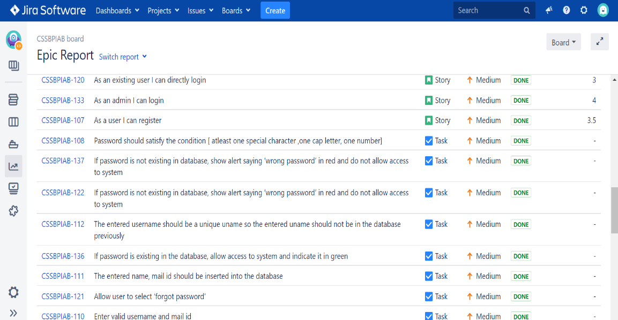

* 1. **Home Page:**

User stories:

* As a user, I can check all the available flights
* As a user, I can check search according to requirements
* As a user, I can check sort according to requirements.
* As a user, I can check todays offers.
* As a user, I can get alerts for flights [based on time and the search element].

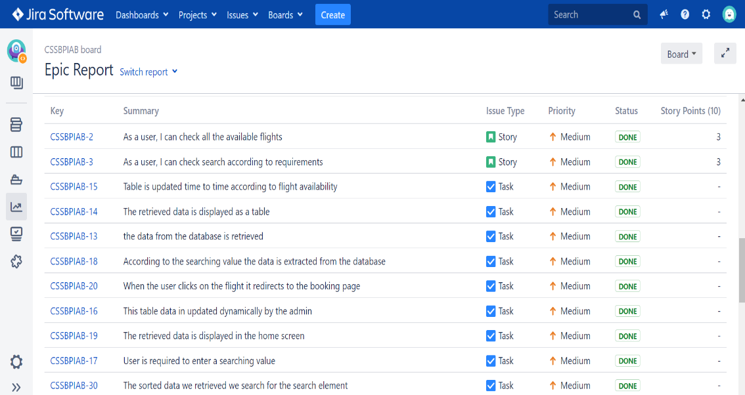

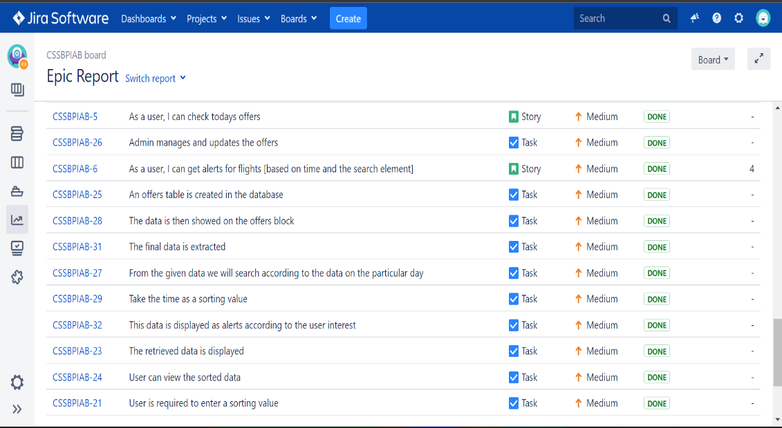

* 1. **Booking Page:**

User stories:

* As a user, I can book flights
* As a user, I can check-in my flight
* As a user, I can generate boarding pass.
* As a user, I can add additional services [discounts, addons, referral].
* As a user, I can clarify my doubts from frequently asked questions.

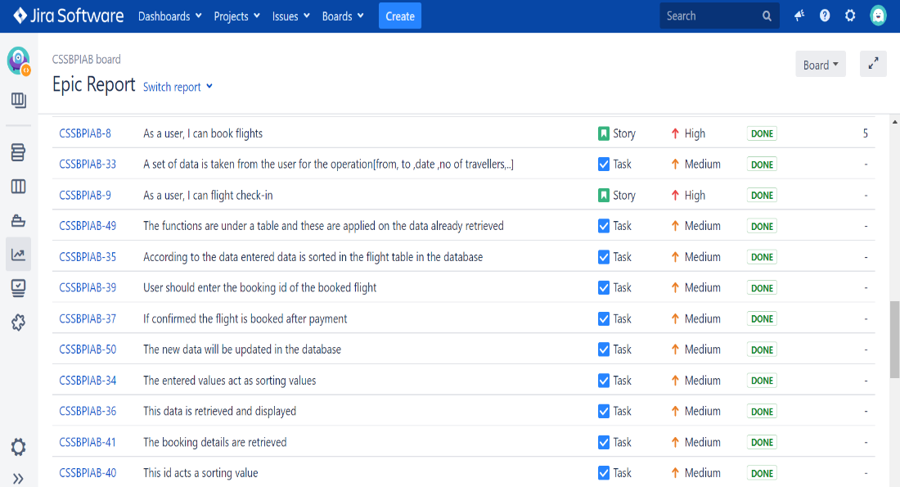

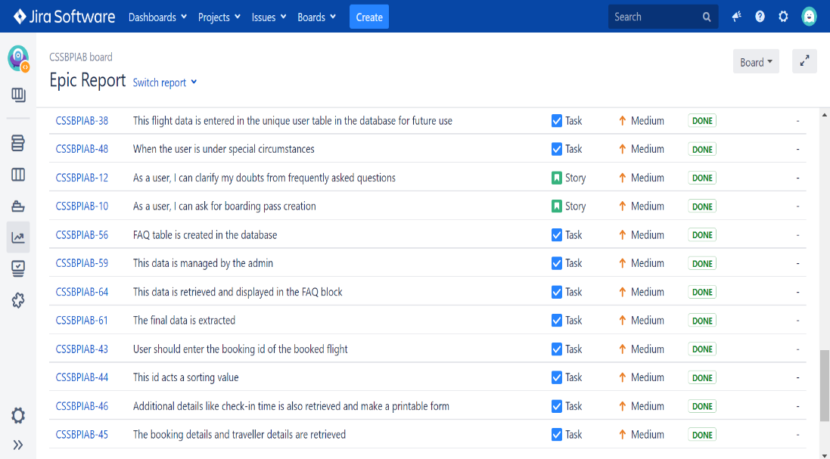

* 1. **Flight Booking Management:**

User stories:

* As a user, I can view booking details
* As a user, I can check flight status
* As a user, I can reschedule flight
* As a user, I can cancel flight booking
* As a user, I can check my refund status

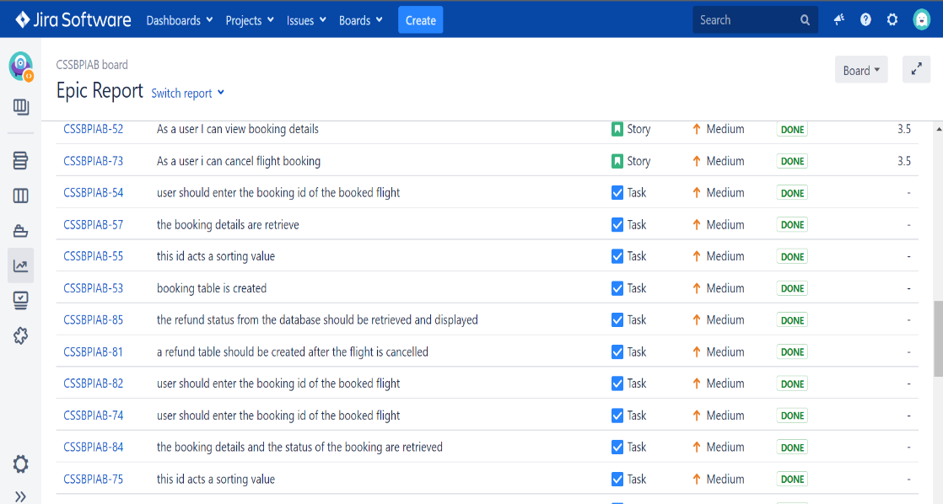

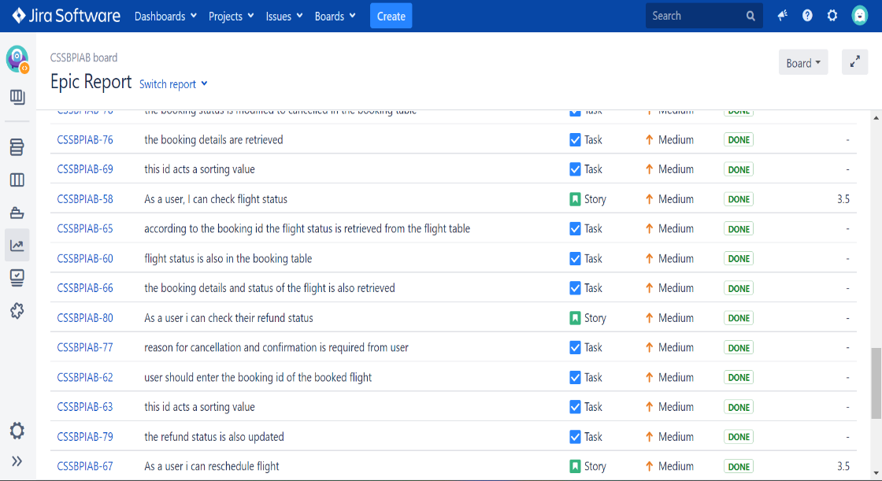

* 1. **Account Management:**

User stories:

* As a user, I can view personal details
* As a user, I can view booking history
* As a user, I can view membership details
* As a user, I can upload documents
* As a user, I would like to have a mandatory health check

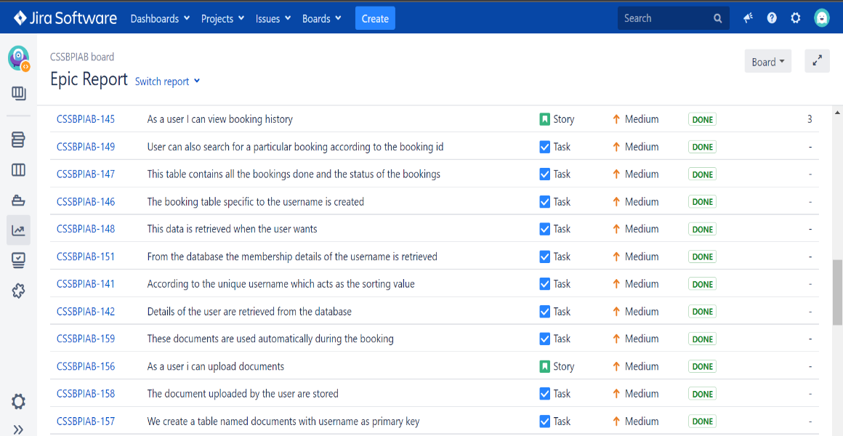

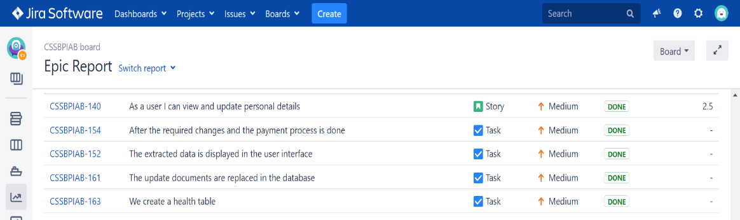

* 1. **Admin UI:**

User stories:

* As an admin, I can view personal details
* As an admin, I can initiate flights
* As an admin, I can manage and update flights
* As an admin, I can manage all the website details

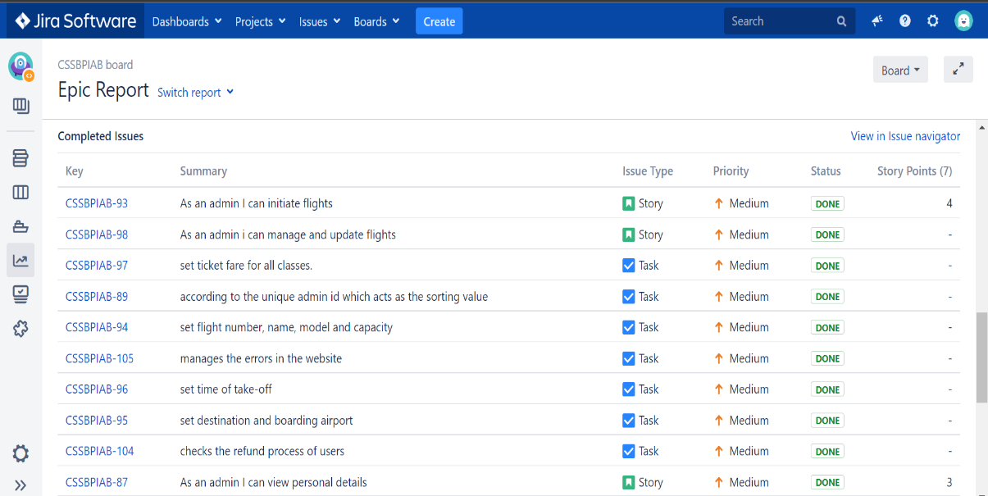

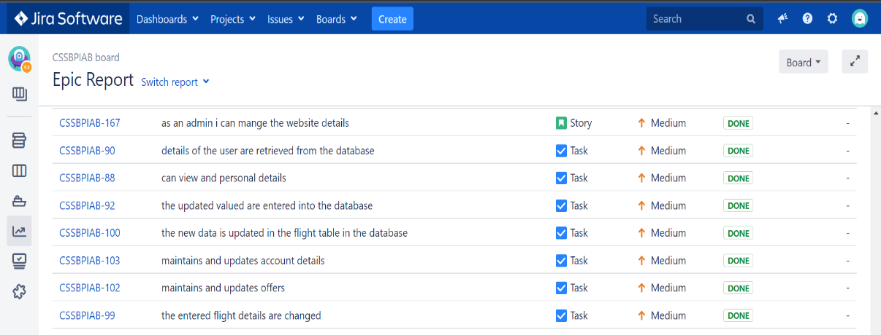

**2.7 Boundaries and Constraints:**

* Once the slots are allocated by admin, the users can change their slots.
* While allocating the details, the user id and seat number should already be present in the database.
* While booking, the arrival and destination details should already be present in the database.
* While registering new user, the new user id shouldn’t be an already existing one

**3. Product Backlog**

3.1 Report of product backlog from JIRA for sprint 1

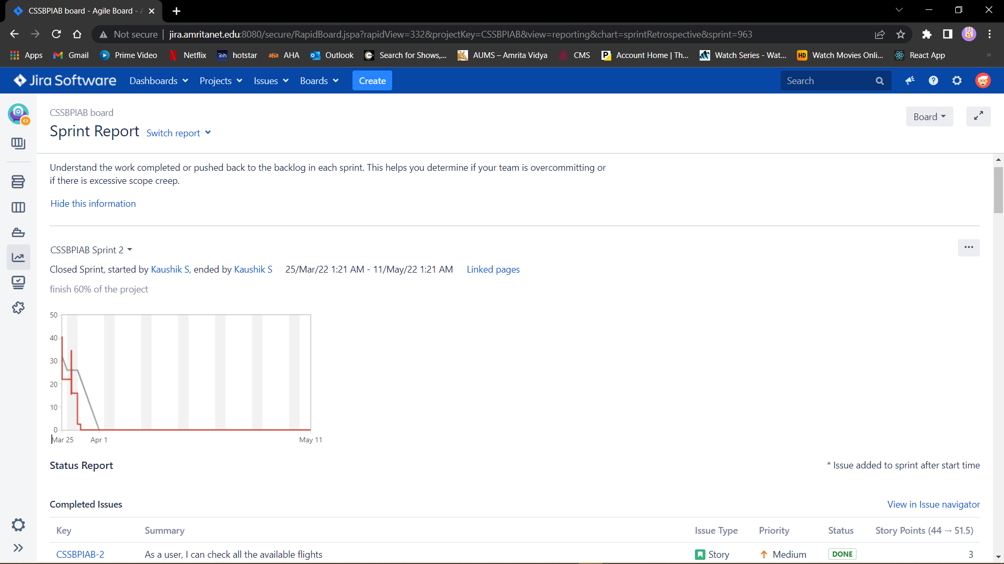

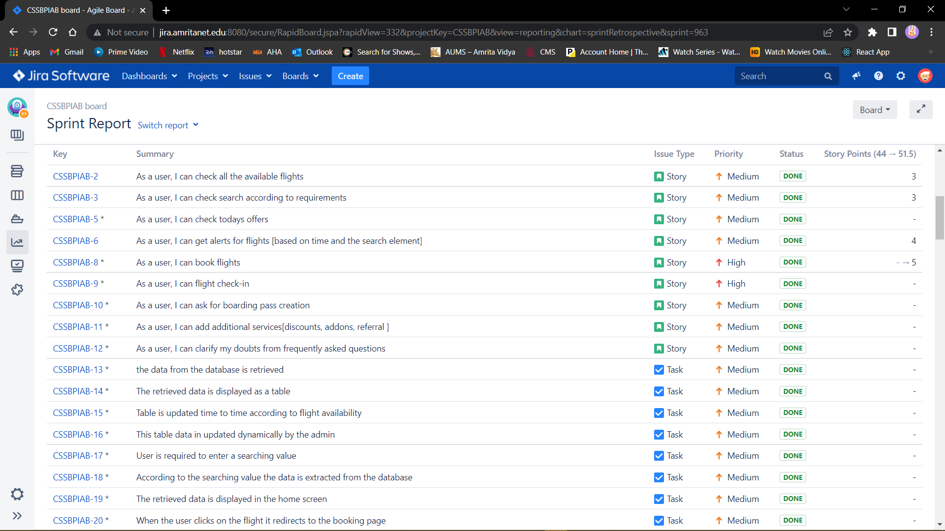



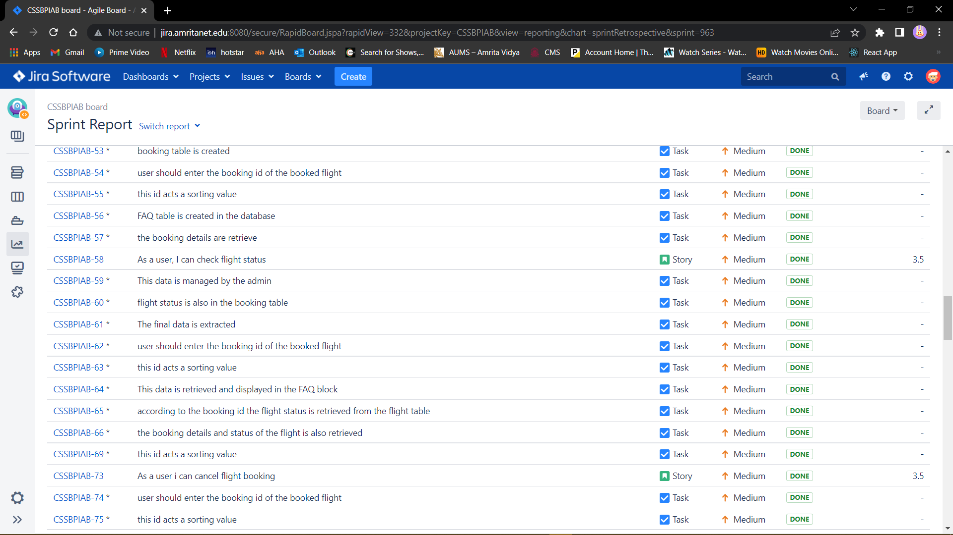

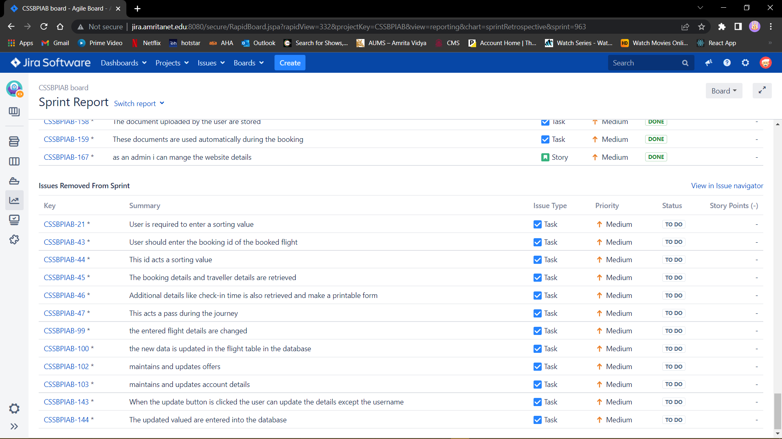

**3.2 Report of product backlog from JIRA for sprint 2**

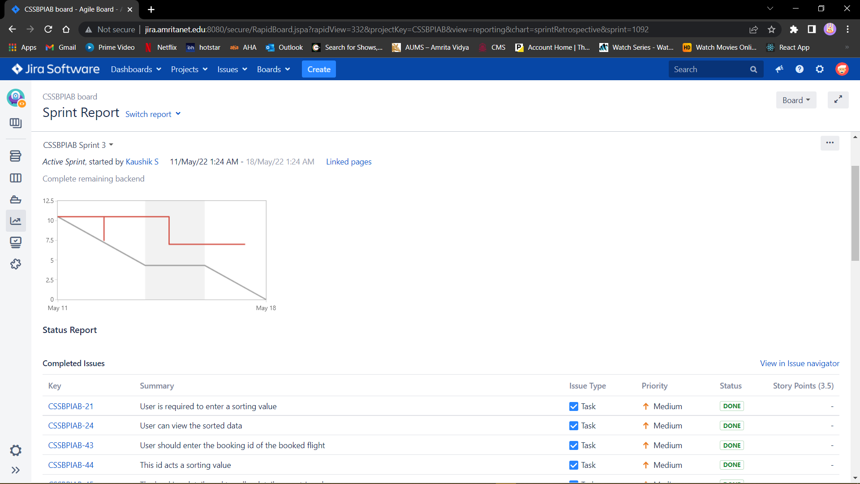

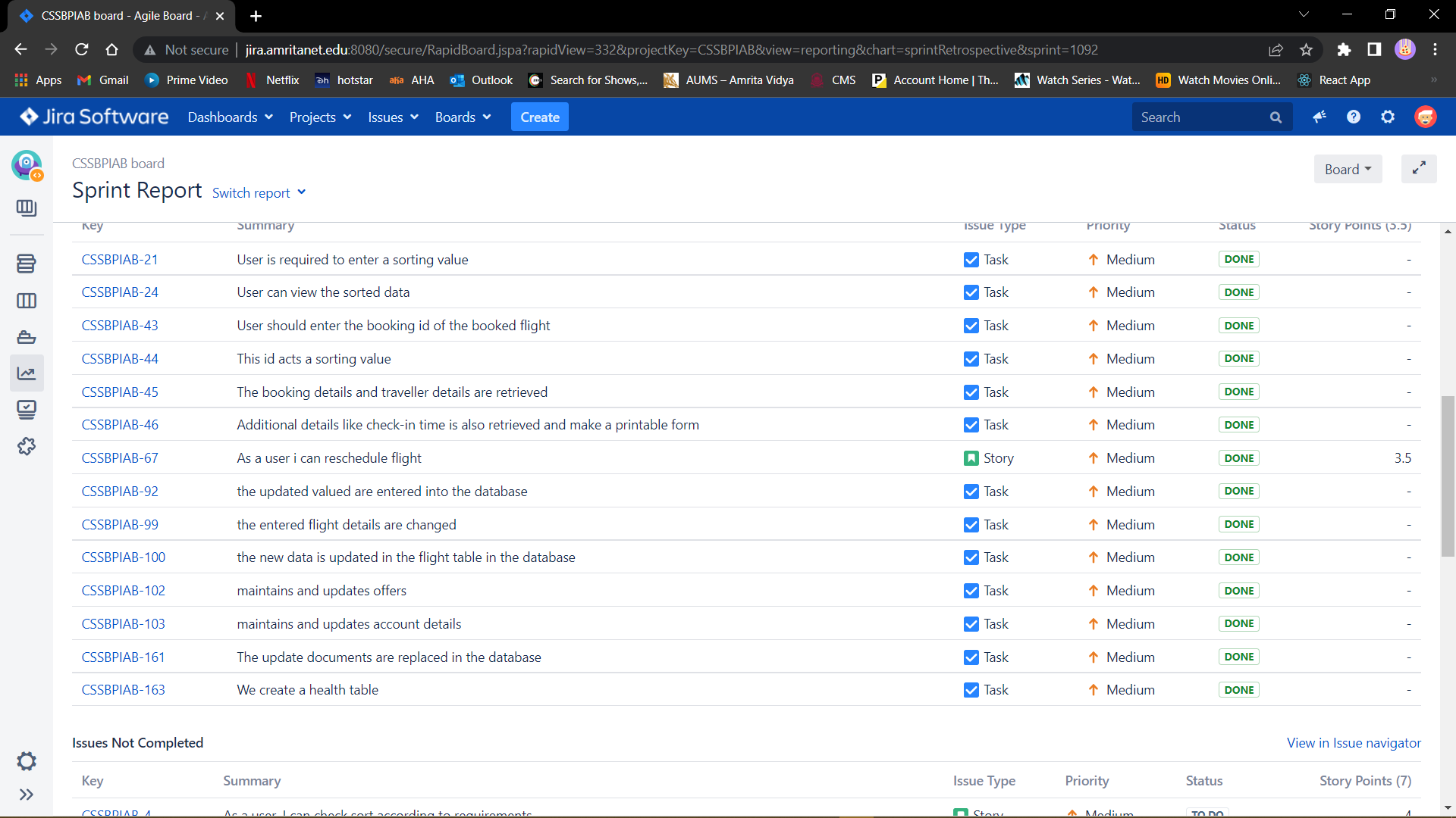

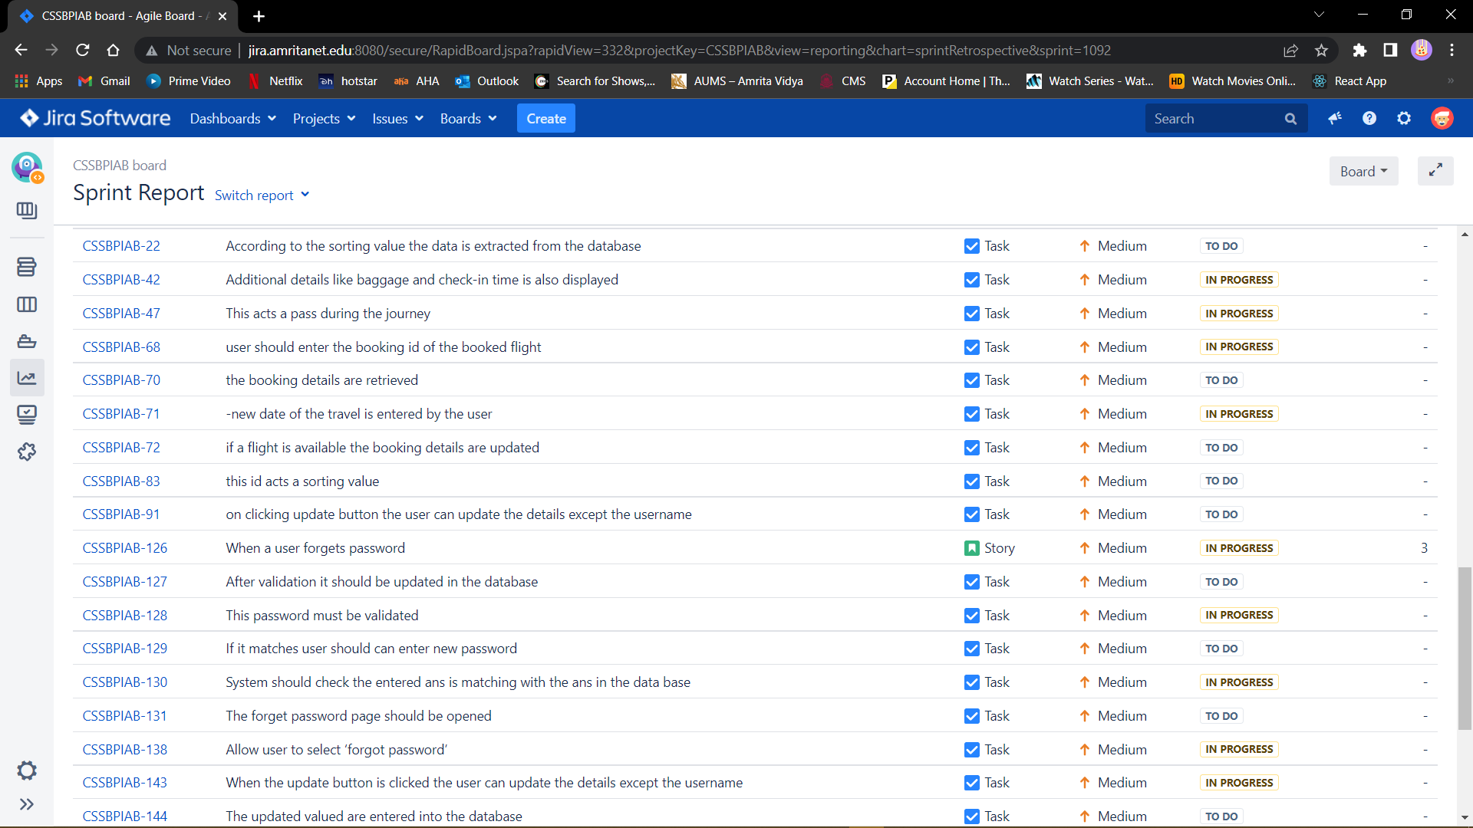

**4 .Diagrams**

## **DFD (Level 2)**

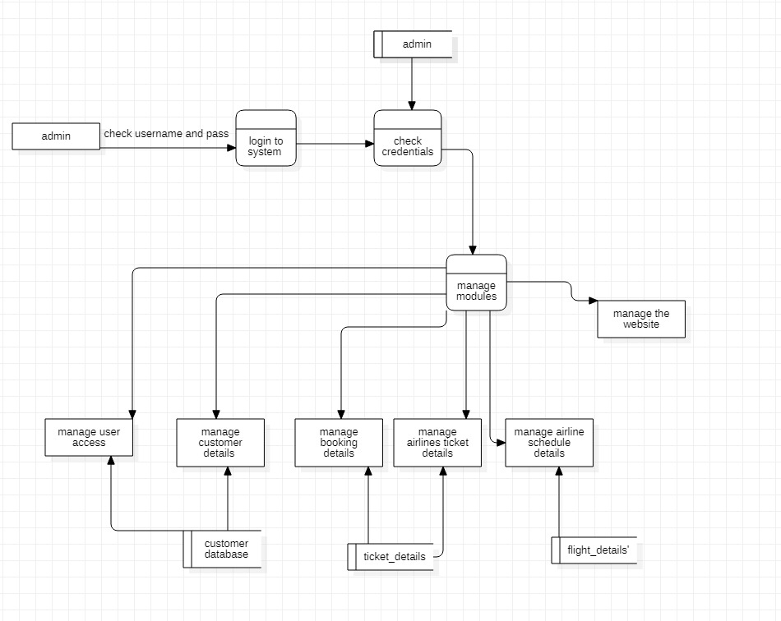

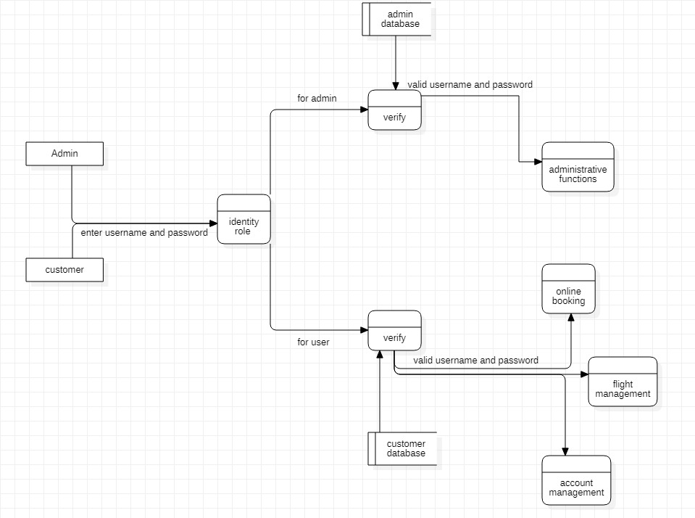

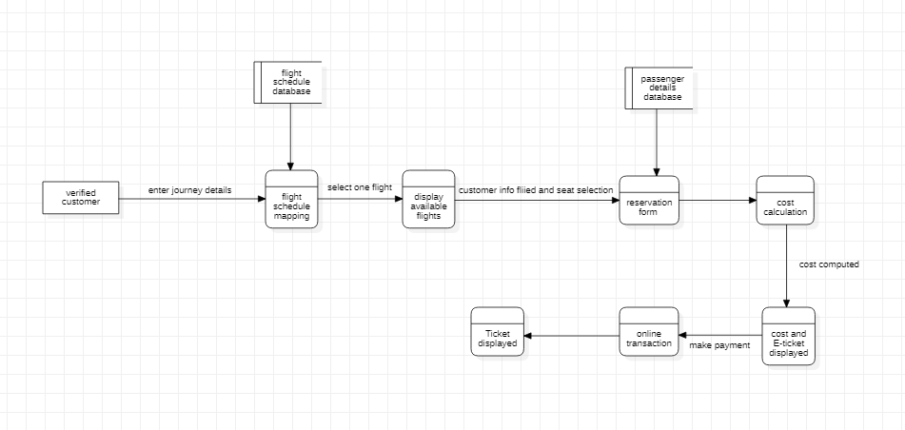

**4.2 Use Case Diagram**

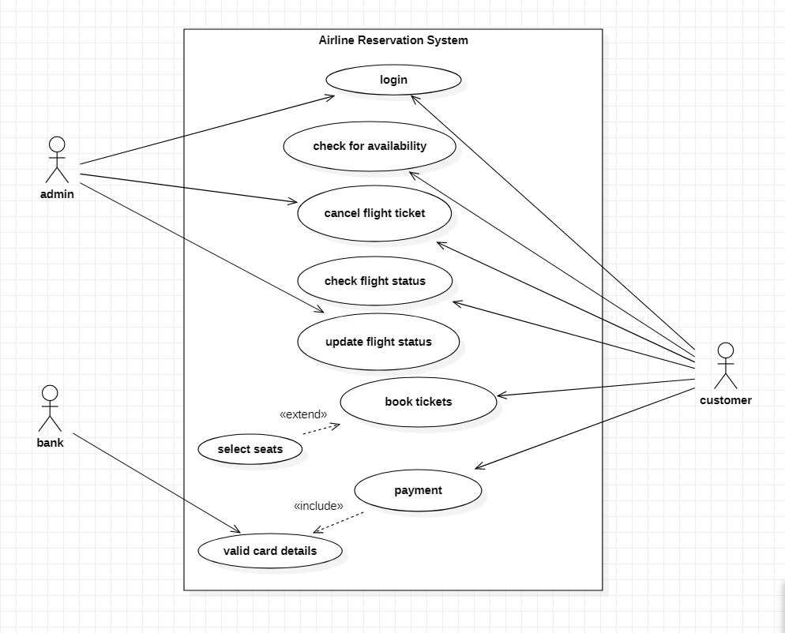

**5. Scrum activities**

* 1. **5.1Sprint 1 backlog sample**

# Epic 1 (Register and Login)

## As a user I can login

|  |  |  |  |
| --- | --- | --- | --- |
| **Task** | **Member** | **Priority** | **Estimate (Hours)** |
| Password satisfaction | Kaushik | Must Have |  |
| Enter Valid password | Kaushik | Must have |  |
| Enter Valid username and mailid | Kaushik | Must Have |  |
| The above details to be entered into database | Kaushik | Must have |  |
| Check for uniqueness of username | Kaushik | Must Have |  |
| Ask for security question and answer | Kaushik | Must Have |  |

## As a user I can select membership type

|  |  |  |  |
| --- | --- | --- | --- |
| **Task** | **Member** | **Priority** | **Estimate (Hours)** |
| Choosing membership type | Kaushik | Should Have |  |
| Ask for payment respectively | Kaushik | Should have |  |
| Receive payment | Kaushik | Must Have |  |
| Display welcome page | Kaushik | Could Have |  |
| Ask user to sign in | Kaushik | Must Have |  |

## As an existing user I can directly login

|  |  |  |  |
| --- | --- | --- | --- |
| **Task** | **Member** | **Priority** | **Estimate (Hours)** |
| Password satisfaction | Kaushik | Must Have |  |
| Enter Valid password | Kaushik | Must have |  |
| Enter Valid username and mailid | Kaushik | Must Have |  |
| The above details to be entered into database | Kaushik | Must have |  |
| Check for uniqueness of username | Kaushik | Must Have |  |
| Ask for security question and answer | Kaushik | Must Have |  |

## When a user forgets password

|  |  |  |  |
| --- | --- | --- | --- |
| **Task** | **Member** | **Priority** | **Estimate (Hours)** |
| After validation it should be updated in the database | Kaushik | Should Have |  |
| This password must be validated | Kaushik | Must have |  |
| If it matches user should can enter new password | Kaushik | Must Have |  |
| System should check the entered answer is matching with the answer in the data base | Kaushik | Should have |  |
| The forget password page should be opened | Kaushik | Must Have |  |

## -As an admin I can login

|  |  |  |  |
| --- | --- | --- | --- |
| **Task** | **Member** | **Priority** | **Estimate (Hours)** |
| -Show the login page (ask to choose between existing or new user) | Kaushik | Should Have |  |
| -Ask for username and password | Kaushik | Must have |  |
| -If password is existing in the database, allow access to system and indicate it in green | Kaushik | Must Have |  |
| -If password is not existing in database, show alert saying ‘wrong password’ in red and do not allow access to system | Kaushik | Must have |  |
| -Allow user to select ‘forgot password’ | Kaushik | Must Have |  |

# Epic 2 (Home Page)

## -As a user i can check all the available flights [list]

|  |  |  |  |
| --- | --- | --- | --- |
| **Task** | **Member** | **Priority** | **Estimate (Hours)** |
| -the data from the database is retrieved | Rhuthvik | Must Have |  |
| -the retrieved data is displayed as a table | Rhuthvik | Should Have |  |
| -table is updated time to time according to flight availability | Rhuthvik | Must Have |  |
| -this table data in updated dynamically by the admin | Rhuthvik | Could Have |  |

## - As a user i can check search according to requirements

|  |  |  |  |
| --- | --- | --- | --- |
| **Task** | **Member** | **Priority** | **Estimate (Hours)** |
| -user is required to enter a searching value | Rhuthvik | Must Have |  |
| -when the user clicks on the flight it redirects to the booking page | Rhuthvik | Must Have |  |
| -table is updated time to time according to flight availability | Rhuthvik | Must Have |  |
| -the retrieved data is displayed in the home screen | Rhuthvik | Must Have |  |

## - As a user i can check sort according to requirements

|  |  |  |  |
| --- | --- | --- | --- |
| **Task** | **Member** | **Priority** | **Estimate (Hours)** |
| -user is required to enter a sorting value | Rhuthvik | Must Have |  |
| -according to the sorting value the data is extracted from the database | Rhuthvik | Must Have |  |
| -the retrieved data is displayed in the home screen | Rhuthvik | Must Have |  |
| -user can view the sorted data | Rhuthvik | Must Have |  |

## - As a user i can check todays offers

|  |  |  |  |
| --- | --- | --- | --- |
| **Task** | **Member** | **Priority** | **Estimate (Hours)** |
| -an offers table is created in the database | Rhuthvik | Must Have |  |
| -admin manages and updates the offers | Rhuthvik | Must Have |  |
| -from the given data we will search according to the data on the particular day | Rhuthvik | Must Have |  |
| -the data is then showed on the offers block | Rhuthvik | Must Have |  |

## - As a user i can get alerts for flights [based on time and the search element]

|  |  |  |  |
| --- | --- | --- | --- |
| **Task** | **Member** | **Priority** | **Estimate (Hours)** |
| -the data from the database is retrieved | Rhuthvik | Must Have |  |
| -then the sorted data we retrieved we search for the search element | Rhuthvik | Must Have |  |
| -the final data is extracted | Rhuthvik | Must Have |  |
| -this data is displayed as alerts according to the user interest | Rhuthvik | Must Have |  |

# Epic 3 (Booking Page)

## -As a user I can book flights

|  |  |  |  |
| --- | --- | --- | --- |
| **Task** | **Member** | **Priority** | **Estimate (Hours)** |
| a set of data is taken from the user for the operation[from, to ,date ,no of travellers,..] | Supriya | Must Have |  |
| the entered values act as sorting values | Supriya | Should Have |  |
| -according to the data entered data is sorted in the flight table in the database | Supriya | Should Have |  |
| -this data is retrieved and displayed | Supriya | Should Have |  |
| -if confirmed the flight is booked after payment | Supriya | Should Have |  |
| -this flight data is entered in the unique user table in the database for future use | Supriya | Should Have |  |

## -As a user I can flight check-in

|  |  |  |  |
| --- | --- | --- | --- |
| **Task** | **Member** | **Priority** | **Estimate (Hours)** |
| -user should enter the booking id of the booked flight | Supriya | Must Have |  |
| -this id acts a sorting value | Supriya | Must Have |  |
| -the booking details are retrieved | Supriya | Must Have |  |
| -additional details like baggage and check-in time is also displayed | Supriya | Must Have |  |

## - As a user i can ask for boarding pass creation

|  |  |  |  |
| --- | --- | --- | --- |
| **Task** | **Member** | **Priority** | **Estimate (Hours)** |
| -user should enter the booking id of the booked flight | Supriya | Must Have |  |
| -this id acts a sorting value | Supriya | Must Have |  |
| -the booking details and traveller details are retrieved | Supriya | Must Have |  |
| -additional details like check-in time is also retrieved and make a printable form | Supriya | Must Have |  |
| -this acts a pass during the journey | Supriya | Must Have |  |

## - As a user i can add additional services[discounts, addons, referral ]

|  |  |  |  |
| --- | --- | --- | --- |
| **Task** | **Member** | **Priority** | **Estimate (Hours)** |
| -when the user is under special circumstances like [student ,army , or has a referral code] | Supriya | Must Have |  |
| -the functions are under a table and these are applied on the data already retrieved | Supriya | Must Have |  |
| -the new data will be updated in the database | Supriya | Must Have |  |

## - As a user i can clarify my doubts from frequently asked questions

|  |  |  |  |
| --- | --- | --- | --- |
| **Task** | **Member** | **Priority** | **Estimate (Hours)** |
| -FAQ table is created in the database | Supriya | Must Have |  |
| -this data is managed by the admin | Supriya | Must Have |  |
| -the final data is extracted | Supriya | Must Have |  |
| -this data is retrieved and displayed in the FAQ block | Supriya | Must Have |  |

# Epic 4 (Flight Booking Page)

## -As a user i can check all the available flights [list]

|  |  |  |  |
| --- | --- | --- | --- |
| **Task** | **Member** | **Priority** | **Estimate (Hours)** |
| -As a user I can view booking details | Leepaakshi | Must Have |  |
| -booking table is created | Leepaakshi | Should Have |  |
| -user should enter the booking id of the booked flight | Leepaakshi | Must Have |  |
| -this id acts a sorting value | Leepaakshi | Could Have |  |
| -the booking details are retrieved | Leepaakshi | Should Have |  |

## -As a user I can check flight status

|  |  |  |  |
| --- | --- | --- | --- |
| **Task** | **Member** | **Priority** | **Estimate (Hours)** |
| -flight status is also in the booking table | Leepaakshi | Must Have |  |
| -user should enter the booking id of the booked flight | Leepaakshi | Must Have |  |
| -this id acts a sorting value | Leepaakshi | Must Have |  |
| -according to the booking id the flight status is retrieved from the flight table | Leepaakshi | Must Have |  |
| -the booking details and status of the flight is also retrieved | Leepaakshi | Should have |  |

## - As a user i can reschedule flight

|  |  |  |  |
| --- | --- | --- | --- |
| **Task** | **Member** | **Priority** | **Estimate (Hours)** |
| -user should enter the booking id of the booked flight | Leepaakshi | Must Have |  |
| -this id acts a sorting value | Leepaakshi | Must Have |  |
| -the booking details are retrieved | Leepaakshi | Must Have |  |
| -new date of the travel is entered by the user | Leepaakshi | Must Have |  |
| -if a flight is available the booking details are updated | Leepaakshi | Must Have |  |

## - As a user i can cancel flight booking

|  |  |  |  |
| --- | --- | --- | --- |
| **Task** | **Member** | **Priority** | **Estimate (Hours)** |
| -user should enter the booking id of the booked flight | Leepaakshi | Must Have |  |
| -this id acts a sorting value | Leepaakshi | Must Have |  |
| -the booking details are retrieved | Leepaakshi | Must Have |  |
| -reason for cancellation and confirmation is required from user | Leepaakshi | Must Have |  |
| -then the booking status is modified to cancelled in the booking table | Leepaakshi | Must Have |  |
| -the refund status is also updated | Leepaakshi | Must Have |  |

## - As a user i can check their refund status

|  |  |  |  |
| --- | --- | --- | --- |
| **Task** | **Member** | **Priority** | **Estimate (Hours)** |
| -a refund table should be created after the flight is cancelled | Leepaakshi | Must Have |  |
| -user should enter the booking id of the booked flight | Leepaakshi | Must Have |  |
| -this id acts a sorting value | Leepaakshi | Must Have |  |
| -the booking details and the status of the booking are retrieved | Leepaakshi | Must Have |  |
| -the refund status from the database should be retrieved and displayed | Leepaakshi |  |  |

# Epic 5 (Account Management Page)

## -As a user I can view and update personal details

|  |  |  |  |
| --- | --- | --- | --- |
| **Task** | **Member** | **Priority** | **Estimate (Hours)** |
| -according to the unique username which acts as the sorting value | Abhiram | Must Have |  |
| -details of the user are retrieved from the database | Abhiram | Should Have |  |
| -according to the data entered data is sorted in the flight -when the update button is clicked the user can update the details except the username in the database | Abhiram | Should Have |  |
| -the updated valued are entered into the database | Abhiram | Should Have |  |

## -As a user I can view booking history

|  |  |  |  |
| --- | --- | --- | --- |
| **Task** | **Member** | **Priority** | **Estimate (Hours)** |
| - the booking table specific to the username is created | Abhiram | Must Have |  |
| - this table contains all the bookings done and the status of the bookings | Abhiram | Must Have |  |
| -this data is retrieved when the user wants | Abhiram | Must Have |  |
| -user can also search for a particular booking according to the booking id | Abhiram | Must Have |  |

## - As a user i can view membership details

|  |  |  |  |
| --- | --- | --- | --- |
| **Task** | **Member** | **Priority** | **Estimate (Hours)** |
| -from the database the membership details of the username is retrieved | Abhiram | Must Have |  |
| -the extracted data is displayed in the user interface | Abhiram | Must Have |  |
| -the membership can be changed if the user wants | Abhiram | Must Have |  |
| -after the required changes and the payment process is done | Abhiram | Must Have |  |
| -the new membership details are updated in the database | Abhiram | Must Have |  |

## - As a user i can upload documents

|  |  |  |  |
| --- | --- | --- | --- |
| **Task** | **Member** | **Priority** | **Estimate (Hours)** |
| -we create a table named documents with username as primary key | Abhiram | Must Have |  |
| -the document uploaded by the user are stored | Abhiram | Must Have |  |
| -these documents are used automatically during the booking | Abhiram | Must Have |  |
| -these documents can be updated by the user | Abhiram | Must Have |  |
| -the update documents are replaced in the database | Abhiram | Must Have |  |

## - As a user i can upload mandatory health declaration

|  |  |  |  |
| --- | --- | --- | --- |
| **Task** | **Member** | **Priority** | **Estimate (Hours)** |
| -we create a health table | Abhiram | Must Have |  |
| -this table contains the health details of the user according to the username | Abhiram | Must Have |  |
| -the status of the covid vaccination is a must | Abhiram | Must Have |  |
| -these details can be updated by the user | Abhiram | Must Have |  |

# Epic 6 (Admin User Interface Page)

## -As an admin I can view and update personal details

|  |  |  |  |
| --- | --- | --- | --- |
| **Task** | **Member** | **Priority** | **Estimate (Hours)** |
| -can view and update personal details | Leepaakshi | Must Have |  |
| -according to the unique admin id which acts as the sorting value | Leepaakshi | Should Have |  |
| -details of the user are retrieved from the database | Leepaakshi | Should Have |  |
| -when the update button is clicked the user can update the details except the username | Leepakshi | Should Have |  |
| -the updated valued are entered into the database | Leepaakshi | Should Have |  |

## -As an admin I can initiate flights

|  |  |  |  |
| --- | --- | --- | --- |
| **Task** | **Member** | **Priority** | **Estimate (Hours)** |
| -set flight number, name, model and capacity | Leepaakshi | Must Have |  |
| -set destination and boarding airport | Leepaakshi | Must Have |  |
| -set time of take-off | Leepaakshi | Must Have |  |
| -set ticket fare for all classes. | Leepaakshi | Must Have |  |

## - As an admin i can manage and update flights

|  |  |  |  |
| --- | --- | --- | --- |
| **Task** | **Member** | **Priority** | **Estimate (Hours)** |
| -the entered flight details are changed | Leepaakshi | Must Have |  |
| -the new data is updated in the flight table in the database | Leepaakshi | Must Have |  |

## - As an admin i can manage all the website details

|  |  |  |  |
| --- | --- | --- | --- |
| **Task** | **Member** | **Priority** | **Estimate (Hours)** |
| -maintains and updates offers | Leepaakshi | Must Have |  |
| - maintains and updates account details | Leepaakshi | Must Have |  |
| -checks the refund process of users | Leepaakshi | Must Have |  |
| -manages the errors in the website | Leepaakshi | Must Have |  |

**5.2 Sprint 1 stand-up notes**

Section: F Project Title: AIRLINE MANAGEMENT SYSTEM

|  |  |  |  |
| --- | --- | --- | --- |
| **Name** | **Question** | **Answer** | **Sign** |
| Sai Chandra Kaushik | What did you do yesterday? | Planned and divided Epics |  |
| What will you do today? | Gathered information for writing user stories |  |
| Are there any impediments in your way? | Yes |  |
| D. Rhuthvik | What did you do yesterday? | Planned and divided Epics |  |
| What will you do today? | Gathered information for writing user stories |  |
| Are there any impediments in your way? | Yes |  |
| G. Leepaakshi | What did you do yesterday? | Planned and divided Epics |  |
| What will you do today? | Gathered information for writing user stories |  |
| Are there any impediments in your way? | Yes |  |
| G. Supriya | What did you do yesterday? | Planned and divided Epics |  |
| What will you do today? | Gathered information for writing user stories |  |
| Are there any impediments in your way? | Yes |  |
| Abhiram Naidu | What did you do yesterday? | Planned and divided Epics |  |
| What will you do today? | Gathered information for writing user stories |  |
| Are there any impediments in your way? | Yes |  |

Faculty Name and Signature:

**AMRITA VISHWA VIDYAPEETHAM Academic Year 2021-22**

# Semester: VI Sem B.Tech 19CSE314 SOFTWARE ENGINEERING

**STANDUP NOTES 2 on 01-02-2022**

Section: F Project Title: AIRLINE MANAGEMENT SYSTEM

|  |  |  |  |
| --- | --- | --- | --- |
| **Name** | **Question** | **Answer** | **Sign** |
| Sai Chandra Kaushik | What did you do yesterday? | Finished writing user stories in the form of charts |  |
| What will you do today? | Using sticky notes ,written user stories In Invison app |  |
| Are there any impediments in your way? | Yes |  |
| D. Rhuthvik | What did you do yesterday? | Finished writing user stories in the form of charts |  |
| What will you do today? | Using sticky notes ,written user stories In Invison app |  |
| Are there any impediments in your way? | Yes |  |
| G. Leepaakshi | What did you do yesterday? | Using sticky notes ,written user stories In Invison app |  |
| What will you do today? | Using sticky notes ,written user stories In Invison app |  |
| Are there any impediments in your way? | Yes |  |
| G. Supriya | What did you do yesterday? | Finished writing user stories in the form of charts |  |
| What will you do today? | Using sticky notes ,written user stories In Invison app |  |
| Are there any impediments in your way? | Yes |  |
| Abhiram Naidu | What did you do yesterday? | Finished writing user stories in the form of charts |  |
| What will you do today? | Using sticky notes ,written user stories In Invison app |  |
| Are there any impediments in your way? | Yes |  |

Faculty Name and Signature:

**AMRITA VISHWA VIDYAPEETHAM Academic Year 2021-22**

# Semester: VI Sem B.Tech 19CSE314 SOFTWARE ENGINEERING

**STANDUP NOTES 3 on 08-02-2022**

Section: F Project Title: AIRLINE MANAGEMENT SYSTEM

|  |  |  |  |
| --- | --- | --- | --- |
| **Name** | **Question** | **Answer** | **Sign** |
| Sai Chandra Kaushik | What did you do yesterday? | Prepared abstract for the project |  |
| What will you do today? | Demonstrated the project and made changes |  |
| Are there any impediments in your way? | Yes |  |
| D. Rhuthvik | What did you do yesterday? | Prepared abstract for the project |  |
| What will you do today? | Demonstrated the project and made changes |  |
| Are there any impediments in your way? | Yes |  |
| G. Leepaakshi | What did you do yesterday? | Prepared abstract for the project |  |
| What will you do today? | Demonstrated the project and made changes |  |
| Are there any impediments in your way? | Yes |  |
| G. Supriya | What did you do yesterday? | Prepared abstract for the project |  |
| What will you do today? | Demonstrated the project and made changes |  |
| Are there any impediments in your way? | Yes |  |
| Abhiram Naidu | What did you do yesterday? | Prepared abstract for the project |  |
| What will you do today? | Demonstrated the project and made changes |  |
| Are there any impediments in your way? | Yes |  |

Faculty Name and Signature:

**AMRITA VISHWA VIDYAPEETHAM Academic Year 2021-22**

# Semester: VI Sem B.Tech 19CSE314 SOFTWARE ENGINEERING

**STANDUP NOTES 4 on 17-02-2022**

Section: F Project Title: AIRLINE MANAGEMENT SYSTEM

|  |  |  |  |
| --- | --- | --- | --- |
| **Name** | **Question** | **Answer** | **Sign** |
| Sai Chandra Kaushik | What did you do yesterday? | Created tables |  |
| What will you do today? | Created forms |  |
| Are there any impediments in your way? | Yes |  |
| D. Rhuthvik | What did you do yesterday? | Created tables |  |
| What will you do today? | Created forms |  |
| Are there any impediments in your way? | Yes |  |
| G. Leepaakshi | What did you do yesterday? | Created tables |  |
| What will you do today? | Created forms |  |
| Are there any impediments in your way? | Yes |  |
| G. Supriya | What did you do yesterday? | Created tables |  |
| What will you do today? | Created forms |  |
| Are there any impediments in your way? | Yes |  |
| Abhiram Naidu | What did you do yesterday? | Created tables |  |
| What will you do today? | Created forms |  |
| Are there any impediments in your way? | Yes |  |

Faculty Name and Signature:

**AMRITA VISHWA VIDYAPEETHAM Academic Year 2021-22**

# Semester: VI Sem B.Tech 19CSE314 SOFTWARE ENGINEERING

**STANDUP NOTES 5 on 23-02-2022**

Section: F Project Title: AIRLINE MANAGEMENT SYSTEM

|  |  |  |  |
| --- | --- | --- | --- |
| **Name** | **Question** | **Answer** | **Sign** |
| Sai Chandra Kaushik | What did you do yesterday? | Identified modules |  |
| What will you do today? | Created Uml Diagram using Star Uml |  |
| Are there any impediments in your way? | Yes |  |
| D. Rhuthvik | What did you do yesterday? | Identified modules |  |
| What will you do today? | Created Uml Diagram using Star Uml |  |
| Are there any impediments in your way? | Yes |  |
| G. Leepaakshi | What did you do yesterday? | Identified modules |  |
| What will you do today? | Created Uml Diagram using Star Uml |  |
| Are there any impediments in your way? | Yes |  |
| G. Supriya | What did you do yesterday? | Identified modules |  |
| What will you do today? | Created Uml Diagram using Star Uml |  |
| Are there any impediments in your way? | Yes |  |
| Abhiram Naidu | What did you do yesterday? | Identified modules |  |
| What will you do today? | Created Uml Diagram using Star Uml |  |
| Are there any impediments in your way? | Yes |  |

Faculty Name and Signature:

**AMRITA VISHWA VIDYAPEETHAM Academic Year 2021-22**

# Semester: VI Sem B.Tech 19CSE314 SOFTWARE ENGINEERING

**STANDUP NOTES 6 on 03-03-2022**

Section: F Project Title: AIRLINE MANAGEMENT SYSTEM

|  |  |  |  |
| --- | --- | --- | --- |
| **Name** | **Question** | **Answer** | **Sign** |
| Sai Chandra Kaushik | What did you do yesterday? | Created Uml Digrams using star uml |  |
| What will you do today? | Created Dfd Diagrams |  |
| Are there any impediments in your way? | Yes |  |
| D. Rhuthvik | What did you do yesterday? | Created Uml Digrams using star uml |  |
| What will you do today? | Created Dfd Diagrams |  |
| Are there any impediments in your way? | Yes |  |
| G. Leepaakshi | What did you do yesterday? | Created Uml Digrams using star uml |  |
| What will you do today? | Created Dfd Diagrams |  |
| Are there any impediments in your way? | Yes |  |
| G. Supriya | What did you do yesterday? | Created Uml Digrams using star uml |  |
| What will you do today? | Created Dfd Diagrams |  |
| Are there any impediments in your way? | Yes |  |
| Abhiram Naidu | What did you do yesterday? | Created Uml Digrams using star uml |  |
| What will you do today? | Created Dfd Diagrams |  |
| Are there any impediments in your way? | Yes |  |

Faculty Name and Signature:

**AMRITA VISHWA VIDYAPEETHAM Academic Year 2021-22**

# Semester: VI Sem B.Tech 19CSE314 SOFTWARE ENGINEERING

**STANDUP NOTES 7 on 13-03-2022**

Section: F Project Title: AIRLINE MANAGEMENT SYSTEM

|  |  |  |  |
| --- | --- | --- | --- |
| **Name** | **Question** | **Answer** | **Sign** |
| Sai Chandra Kaushik | What did you do yesterday? | Created Dfd Diagrams |  |
| What will you do today? | Updated in Github |  |
| Are there any impediments in your way? | Yes |  |
| D. Rhuthvik | What did you do yesterday? | Created Dfd Diagrams |  |
| What will you do today? | Updated in Github |  |
| Are there any impediments in your way? | Yes |  |
| G. Leepaakshi | What did you do yesterday? | Created Dfd Diagrams |  |
| What will you do today? | Updated in Github |  |
| Are there any impediments in your way? | Yes |  |
| G. Supriya | What did you do yesterday? | Created Dfd Diagrams |  |
| What will you do today? | Updated in Github |  |
| Are there any impediments in your way? | Yes |  |
| Abhiram Naidu | What did you do yesterday? | Created Dfd Diagrams |  |
| What will you do today? | Updated in Github |  |
| Are there any impediments in your way? | Yes |  |

Faculty Name and Signature:

**AMRITA VISHWA VIDYAPEETHAM Academic Year 2021-22**

# Semester: VI Sem B.Tech 19CSE314 SOFTWARE ENGINEERING

**STANDUP NOTES 8 on 22-03-2022**

Section: F Project Title: AIRLINE MANAGEMENT SYSTEM

|  |  |  |  |
| --- | --- | --- | --- |
| **Name** | **Question** | **Answer** | **Sign** |
| Sai Chandra Kaushik | What did you do yesterday? | Started creating jira account and filled issues |  |
| What will you do today? | Completed writing user stories and epics with summary |  |
| Are there any impediments in your way? | Yes |  |
| D. Rhuthvik | What did you do yesterday? | Started creating jira account and filled issues |  |
| What will you do today? | Completed writing user stories and epics with summary |  |
| Are there any impediments in your way? | Yes |  |
| G. Leepaakshi | What did you do yesterday? | Started creating jira account and filled issues |  |
| What will you do today? | Completed writing user stories and epics with summary |  |
| Are there any impediments in your way? | Yes |  |
| G. Supriya | What did you do yesterday? | Started creating jira account and filled issues |  |
| What will you do today? | Completed writing user stories and epics with summary |  |
| Are there any impediments in your way? | Yes |  |
| Abhiram Naidu | What did you do yesterday? | Started creating jira account and filled issues |  |
| What will you do today? | Completed writing user stories and epics with summary |  |
| Are there any impediments in your way? | Yes |  |

Faculty Name and Signature:

**5.3 Sprint 1 retrospective notes:-**

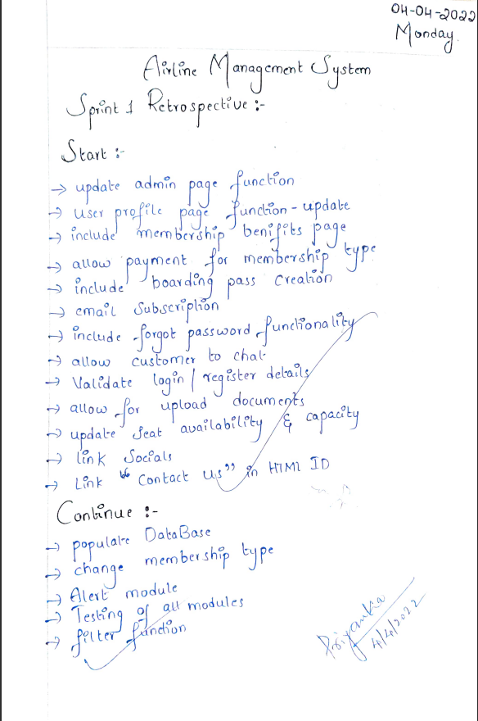

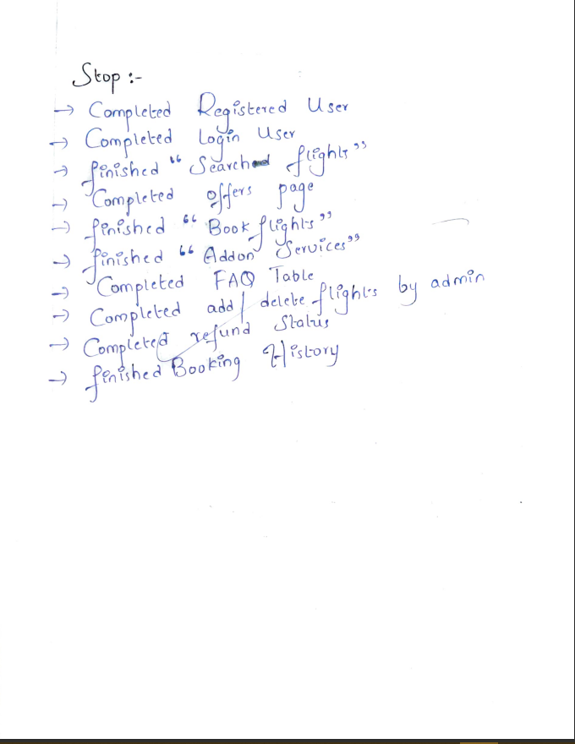

5.4 Burndown Charts based on Story Points for Sprint 1:

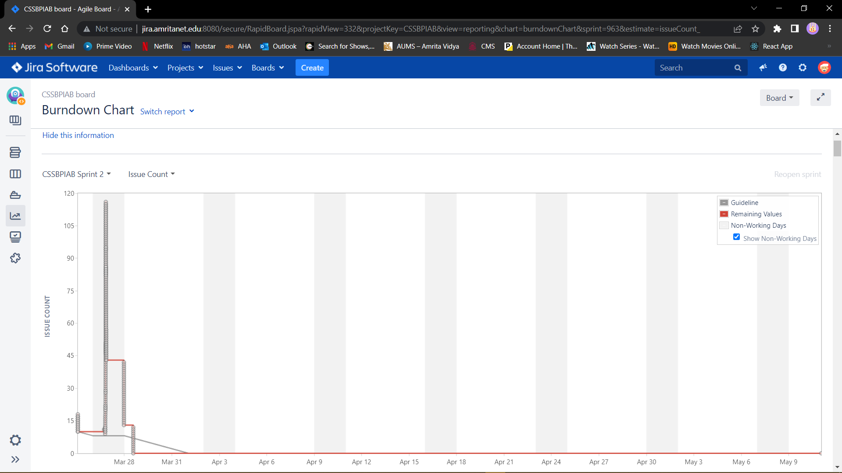

**5.5 Sprint 2 standup notes**

**AMRITA VISHWA VIDYAPEETHAM Academic Year 2021-22**

# Semester: VI Sem B.Tech 19CSE314 SOFTWARE ENGINEERING

**STANDUP NOTES 9 on 26-03-2022**

Section: F Project Title: AIRLINE MANAGEMENT SYSTEM

|  |  |  |  |
| --- | --- | --- | --- |
| **Name** | **Question** | **Answer** | **Sign** |
| Sai Chandra Kaushik | What did you do yesterday? | Discussed about the sprint restrospective notes after sprint 1 |  |
| What will you do today? | Assissted in finishing up the front end |  |
| Are there any impediments in your way? | No |  |
| D. Rhuthvik | What did you do yesterday? | Discussed about the sprint restrospective notes after sprint 1 |  |
| What will you do today? | Assissted in finishing up the front end |  |
| Are there any impediments in your way? | No |  |
| G. Leepaakshi | What did you do yesterday? | Discussed about the sprint restrospective notes after sprint 1 |  |
| What will you do today? | Assissted in finishing up the front end |  |
| Are there any impediments in your way? | No |  |
| G. Supriya | What did you do yesterday? | Discussed about the sprint restrospective notes after sprint 1 |  |
| What will you do today? | Assissted in finishing up the front end |  |
| Are there any impediments in your way? | Yes |  |
| Abhiram Naidu | What did you do yesterday? | Discussed about the sprint restrospective notes after sprint 1 |  |
| What will you do today? | Assissted in finishing up the front end |  |
| Are there any impediments in your way? | No |  |

Faculty Name and Signature:

**AMRITA VISHWA VIDYAPEETHAM Academic Year 2021-22**

# Semester: VI Sem B.Tech 19CSE314 SOFTWARE ENGINEERING

**STANDUP NOTES 10 on 02-04-2022**

Section: F Project Title: AIRLINE MANAGEMENT SYSTEM

|  |  |  |  |
| --- | --- | --- | --- |
| **Name** | **Question** | **Answer** | **Sign** |
| Sai Chandra Kaushik | What did you do yesterday? | Assisted in finishing up the web application |  |
| What will you do today? | Assisted with web application styling |  |
| Are there any impediments in your way? | Padding issues and margin issues |  |
| D. Rhuthvik | What did you do yesterday? | Assisted in developing Backend APIs |  |
| What will you do today? | Installation and configuration of testing tools |  |
| Are there any impediments in your way? | Installation hurdles |  |
| G. Leepaakshi | What did you do yesterday? | Assisted in finishing up the Front End |  |
| What will you do today? | Assisted in styling(CSS) |  |
| Are there any impediments in your way? | Navigation errors or linking errors |  |
| G. Supriya | What did you do yesterday? | Assisted in finishing up the Front End |  |
| What will you do today? | Assisted in styling mobile application pages |  |
| Are there any impediments in your way? | Navigation errors or linking errors |  |
| Abhiram Naidu | What did you do yesterday? | Designed Html pages, css style sheets |  |
| What will you do today? | Implemented in visual studio |  |
| Are there any impediments in your way? | Yes |  |

Faculty Name and Signature:

**AMRITA VISHWA VIDYAPEETHAM Academic Year 2021-22**

# Semester: VI Sem B.Tech 19CSE314 SOFTWARE ENGINEERING

**STANDUP NOTES 11 on 09-04-2022**

Section: F Project Title: AIRLINE MANAGEMENT SYSTEM

|  |  |  |  |
| --- | --- | --- | --- |
| **Name** | **Question** | **Answer** | **Sign** |
| Sai Chandra Kaushik | What did you do yesterday? | Designed Html pages, css style sheets |  |
| What will you do today? | Implemented in visual studio |  |
| Are there any impediments in your way? | Yes |  |
| D. Rhuthvik | What did you do yesterday? | Designed Html pages, css style sheets |  |
| What will you do today? | Implemented in visual studio |  |
| Are there any impediments in your way? | Yes |  |
| G. Leepaakshi | What did you do yesterday? | Designed Html pages, css style sheets |  |
| What will you do today? | Implemented in visual studio |  |
| Are there any impediments in your way? | Yes |  |
| G. Supriya | What did you do yesterday? | Designed Html pages, css style sheets |  |
| What will you do today? | Implemented in visual studio |  |
| Are there any impediments in your way? | Yes |  |
| Abhiram Naidu | What did you do yesterday? | Designed Html pages, css style sheets |  |
| What will you do today? | Implemented in visual studio |  |
| Are there any impediments in your way? | Yes |  |

Faculty Name and Signature:

**AMRITA VISHWA VIDYAPEETHAM Academic Year 2021-22**

# Semester: VI Sem B.Tech 19CSE314 SOFTWARE ENGINEERING

**STANDUP NOTES 12 on 17-04-2022**

Section: F Project Title: AIRLINE MANAGEMENT SYSTEM

|  |  |  |  |
| --- | --- | --- | --- |
| **Name** | **Question** | **Answer** | **Sign** |
| Sai Chandra Kaushik | What did you do yesterday? | Designed Html pages, css style sheets |  |
| What will you do today? | Implemented in visual studio |  |
| Are there any impediments in your way? | Yes |  |
| D. Rhuthvik | What did you do yesterday? | Designed Html pages, css style sheets |  |
| What will you do today? | Implemented in visual studio |  |
| Are there any impediments in your way? | Yes |  |
| G. Leepaakshi | What did you do yesterday? | Designed Html pages, css style sheets |  |
| What will you do today? | Implemented in visual studio |  |
| Are there any impediments in your way? | Yes |  |
| G. Supriya | What did you do yesterday? | Designed Html pages, css style sheets |  |
| What will you do today? | Implemented in visual studio |  |
| Are there any impediments in your way? | Yes |  |
| Abhiram Naidu | What did you do yesterday? | Designed Html pages, css style sheets |  |
| What will you do today? | Implemented in visual studio |  |
| Are there any impediments in your way? | Yes |  |

Faculty Name and Signature:

**5.6 Sprint 2 retrospective notes:**

To be completed after sprint.

**5.7 Burndown chart for sprint2**

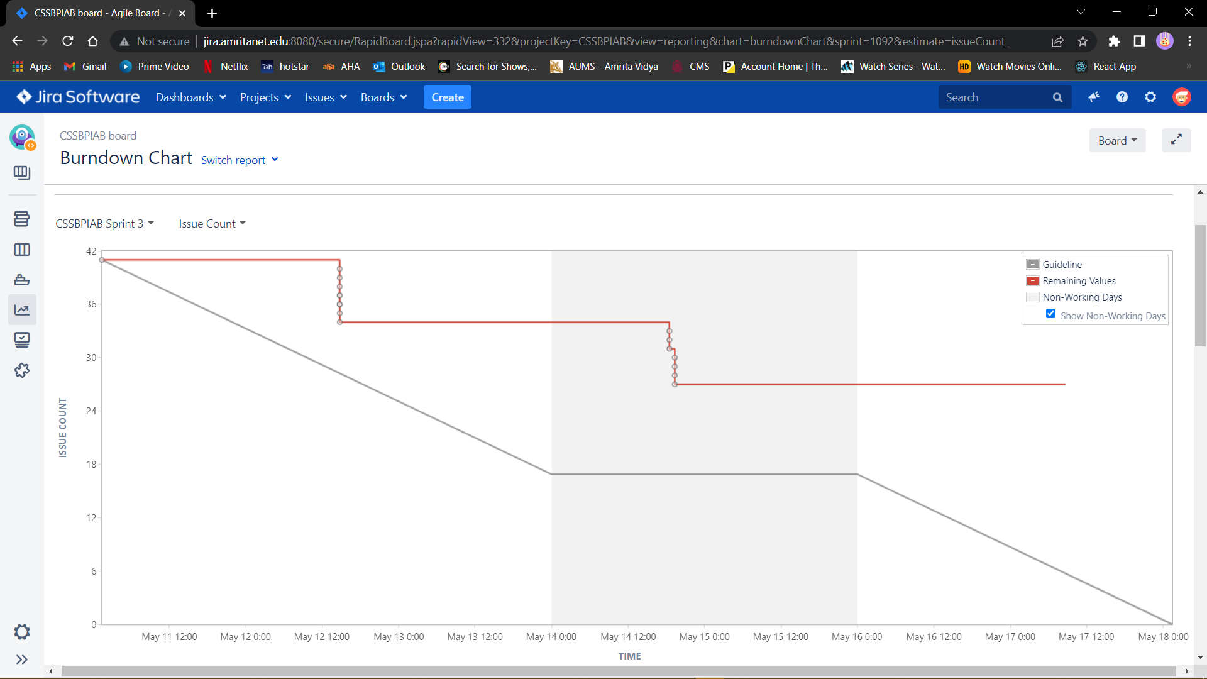

**6. Implementation:**

**Tools:**

1. VS- Code – Editor
2. XAMPP – Web Server
3. Phpmyadmin - **MySQL Database Management**

**Languages Used:**

1. HTML/CSS/JS
2. PHP
3. SQL

**Project Link:** <https://github.com/Rhuthvik-D/Airline-Management-System>

**Invision Link :** <https://drhuthvik779627.invisionapp.com/freehand/Airline-Management-uiLgXOVxb>

**7. Sample Code:**

<?php

    session_start();

?>

<html>

    <head>

        <title>

            Welcome to Blu Airlines

        </title>

        <link rel="stylesheet" type="text/css" href="css/style.css"/>

        <link rel="stylesheet" href="font-awesome-4.7.0\css\font-awesome.min.css">

        <link rel="stylesheet" href="https://fonts.googleapis.com/css?family=Tangerine">

        <link rel="preconnect" href="https://fonts.googleapis.com">

        <link rel="preconnect" href="https://fonts.gstatic.com" crossorigin>

        <link href="https://fonts.googleapis.com/css2?family=Dancing+Script:wght@700&display=swap" rel="stylesheet">

        <link rel="stylesheet" href="https://www.w3schools.com/w3css/4/w3.css">

        <link rel="stylesheet" href="https://fonts.googleapis.com/css?family=Tangerine">

        <link rel="stylesheet" href="https://cdnjs.cloudflare.com/ajax/libs/font-awesome/4.7.0/css/font-awesome.css">

        <link rel="stylesheet" href="css1.css">

        <link rel="preconnect" href="https://fonts.googleapis.com">

        <link rel="preconnect" href="https://fonts.gstatic.com" crossorigin>

        <link href="https://fonts.googleapis.com/css2?family=Dancing+Script:wght@700&display=swap" rel="stylesheet">

        <link rel="stylesheet" href="header.css">

        <style>

        body,h1,h2,h3,h4,h5,h6 {font-family: 'Montserrat', sans-serif;}

        .myLink {display: none}

        img.center {

            display: flex;

           align-items:center;

}

        @import url('https://fonts.googleapis.com/css?family=Montserrat:400,800');

    </style>

    <script src="https://kit.fontawesome.com/e90b3f623b.js" crossorigin="anonymous"></script>

    </head>

    <body style="background-image: url('images/cloud.jpg');background-repeat: no-repeat; background-size: 1600px 2400px;background-position:bottom;">

        <div class="center">

    <img  src="images\air.jpg" width="80px" height="80px" />

        <h1 id="title" style="color:rgb(14, 118, 187);font-family:'Dancing Script', cursive;font-size: 65px;">

            Blu Airways

        </h1>

        </div>

        <div id="left_side">

            <ul>

                <li><a href="home_page.php"><i class="fa fa-home" aria-hidden="true"></i> Home</a></li>

                <li>

                    <?php

                        if(isset($_SESSION['login_user'])&&$_SESSION['user_type']=='Customer')

                        {

                            echo "<a href=\"book_tickets.php\"><i class=\"fa fa-ticket\" aria-hidden=\"true\"></i> Book Tickets</a>";

                        }

                        else if(isset($_SESSION['login_user'])&&$_SESSION['user_type']=='Administrator')

                        {

                            echo "<a href=\"admin_ticket_message.php\"><i class=\"fa fa-ticket\" aria-hidden=\"true\"></i> Book Tickets</a>";

                        }

                        else

                        {

                            echo "<a href=\"login_page.php\"><i class=\"fa fa-ticket\" aria-hidden=\"true\"></i> Book Tickets</a>";

                        }

                    ?>

                </li>

                <li><a href="index.html"><i class="fa fa-plane" aria-hidden="true"></i> FAQ</a></li>

                <li><a href="offers.html"><i class="fa fa-plane" aria-hidden="true"></i> Offers</a></li>

                <li><a href="home_page.php"><i class="fa fa-phone" aria-hidden="true"></i> Contact Us</a></li>

                <li>

                    <?php

                        if(isset($_SESSION['login_user'])&&$_SESSION['user_type']=='Customer')

                        {

                            echo "<a href=\"customer_homepage.php\"><i class=\"fa fa-sign-in\" aria-hidden=\"true\"></i> Login</a>";

                        }

                        else if(isset($_SESSION['login_user'])&&$_SESSION['user_type']=='Administrator')

                        {

                            echo "<a href=\"admin_homepage.php\"><i class=\"fa fa-sign-in\" aria-hidden=\"true\"></i> Login</a>";

                        }

                        else

                        {

                            echo "<a href=\"login_page.php\"><i class=\"fa fa-sign-in\" aria-hidden=\"true\"></i> Login</a>";

                        }

                    ?>

                </li>

            </ul>

        </div>

        <div class="container">

<!-- Header -->

<header class="w3-display-container w3-content w3-hide-small" style="max-width:1500px;height: 300px;">

 <div class="w3-display-middle" style="width:72%">

   <div class="w3-bar w3-black">

     <button class="w3-bar-item w3-button tablink" onclick="openLink(event, 'Alerted');"><i class="fa-solid fa-bell"></i> Alerted</button>

     <button class="w3-bar-item w3-button tablink" onclick="openLink(event, 'Offer');"><i class="fa-solid fa-circle-exclamation w3-margin-right"></i>Offers</button>

   </div>

   <!-- Tabs -->

   <div id="Alerted" class="w3-container w3-white w3-padding-16 myLink">

     <h3>Stay <text class="w3-text-blue">alerted</text> all the time. </h3>

     <p>Book a flight with us and get alerts at crucial times.</p>

     <p><button class="w3-button w3-dark-grey w3-red">Click to get alerts</button></p>

   </div>

   <div id="Offer" class="w3-container w3-white w3-padding-16 myLink">

     <h3>Find Your Suitable Offer</h3>

     <p><span class="w3-tag w3-blue">DISCOUNT!</span> Multiple Offers available for your convenience.</p>

     <input class="w3-input w3-border" type="text" placeholder="Date of Departure">

     <p><button class="w3-button w3-dark-grey">Search Offers</button></p>

   </div>

</div>

</header>

<!-- Page content -->

<div class="w3-content" style="max-width:1100px;">

 <!-- Good offers -->

 <div class="w3-container w3-margin-top">

   <h3>Good Offers Right Now</h3>

   <h6>Up to <strong>50%</strong> discount.</h6>

 </div>

 <div class="w3-row-padding w3-text-white w3-large">

   <div class="w3-half w3-margin-bottom">

     <div class="w3-display-container">

       <img src="https://www.w3schools.com/w3images/cinqueterre.jpg" alt="Cinque Terre" style="width:100%">

       <span class="w3-display-bottomleft w3-padding">Cinque Terre</span>

     </div>

   </div>

   <div class="w3-half">

     <div class="w3-row-padding" style="margin:0 -16px">

       <div class="w3-half w3-margin-bottom">

         <div class="w3-display-container">

           <img src="https://www.w3schools.com/w3images/newyork2.jpg" alt="New York" style="width:100%">

           <span class="w3-display-bottomleft w3-padding">New York</span>

         </div>

       </div>

       <div class="w3-half w3-margin-bottom">

         <div class="w3-display-container">

           <img src="https://www.w3schools.com/w3images/sanfran.jpg" alt="San Francisco" style="width:100%">

           <span class="w3-display-bottomleft w3-padding">San Francisco</span>

         </div>

       </div>

     </div>

     <div class="w3-row-padding" style="margin:0 -16px">

       <div class="w3-half w3-margin-bottom">

         <div class="w3-display-container">

           <img src="https://www.w3schools.com/w3images/pisa.jpg" alt="Pisa" style="width:100%">

           <span class="w3-display-bottomleft w3-padding">Pisa</span>

         </div>

       </div>

       <div class="w3-half w3-margin-bottom">

         <div class="w3-display-container">

           <img src="https://www.w3schools.com/w3images/paris.jpg" alt="Paris" style="width:100%">

           <span class="w3-display-bottomleft w3-padding">Paris</span>

         </div>

       </div>

     </div>

   </div>

 </div>

 <!-- Explore Nature -->

 <div class="w3-container">

   <h3>Explore India</h3>

   <p>Travel with us and see nature at its finest.</p>

 </div>

 <div class="w3-row-padding">

   <div class="w3-half w3-margin-bottom">

     <img src="https://cdn.britannica.com/37/189837-050-F0AF383E/New-Delhi-India-War-Memorial-arch-Sir.jpg" alt="Delhi" style="width:100%" >

     <div class="w3-container w3-white">

       <h3>Delhi, India</h3>

       <p class="w3-opacity">Roundtrip from 6000/-</p>

       <a href="book_tickets.php"><button class="w3-button w3-margin-bottom">Buy Tickets</button></a>

     </div>

   </div>

   <div class="w3-half w3-margin-bottom">

     <img src="https://thetravelhack.com/wp-content/uploads/2020/06/Kerala-backwaters.jpeg" alt="Austria" style="width:100%">

     <div class="w3-container w3-white">

       <h3>Kerala, India</h3>

       <p class="w3-opacity">One-way from 3000/-</p>

      <a href="book_tickets.php"> <button class="w3-button w3-margin-bottom">Buy Tickets</button></a>

     </div>

   </div>

 </div>

 <!-- Newsletter -->

 <div class="w3-container">

   <div class="w3-panel w3-padding-16 w3-black w3-opacity w3-card w3-hover-opacity-off">

     <h2>Get the best offers first!</h2>

     <p>Join our newsletter.</p>

     <label>E-mail</label>

     <input class="w3-input w3-border" type="text" placeholder="Your Email address">

     <button type="button" class="w3-button w3-blue w3-margin-top">Subscribe</button>

   </div>

 </div>

 <!-- Contact -->

 <div class="w3-container">

   <h2>Contact</h2>

   <p>Let us book your next trip!</p>

   <i class="fa fa-map-marker" style="width:30px"></i> Coimbatore, TN<br>

   <i class="fa fa-phone" style="width:30px"></i> Phone: +91 9876543210<br>

   <i class="fa fa-envelope" style="width:30px"> </i> Email: mail@mail.com<br>

   <form action="/action_page.php" target="_blank">

     <p><input class="w3-input w3-padding-16 w3-border" type="text" placeholder="Name" required name="Name"></p>

     <p><input class="w3-input w3-padding-16 w3-border" type="text" placeholder="Email" required name="Email"></p>

     <p><input class="w3-input w3-padding-16 w3-border" type="text" placeholder="Message" required name="Message"></p>

     <a href="login_page.php"><button class="w3-button w3-blue w3-padding-large" type="submit">SEND MESSAGE</button></a>

   </form>

 </div>

<!-- End page content -->

</div>

<!-- Footer -->

<footer class="w3-container w3-center w3-opacity w3-margin-bottom">

 <h5>Find Us On</h5>

 <div class="w3-xlarge w3-padding-16">

   <i class="fa fa-facebook-official w3-hover-opacity"></i>

   <i class="fa fa-instagram w3-hover-opacity"></i>

   <i class="fa fa-snapchat w3-hover-opacity"></i>

   <i class="fa fa-pinterest-p w3-hover-opacity"></i>

   <i class="fa fa-twitter w3-hover-opacity"></i>

   <i class="fa fa-linkedin w3-hover-opacity"></i>

 </div>

 <p>Developed by <a href="#" target="_blank" class="w3-hover-text-blue">CSE-F</a></p>

</footer>

<script>

// Tabs

function openLink(evt, linkName) {

 var i, x, tablinks;

 x = document.getElementsByClassName("myLink");

 for (i = 0; i < x.length; i++) {

   x[i].style.display = "none";

 }

 tablinks = document.getElementsByClassName("tablink");

 for (i = 0; i < x.length; i++) {

   tablinks[i].className = tablinks[i].className.replace(" w3-blue", "");

 }

 document.getElementById(linkName).style.display = "block";

 evt.currentTarget.className += " w3-blue";

}

// Click on the first tablink on load

document.getElementsByClassName("tablink")[0].click();

</script>

        </div>

        <!--check out addling local host in links and other places

            shift login/logout buttons to right side

        -->

    </body>

</html

# 8.Software Engineering tools used

**8.1.: STATIC CODE ANALYSIS(using phpstan):**

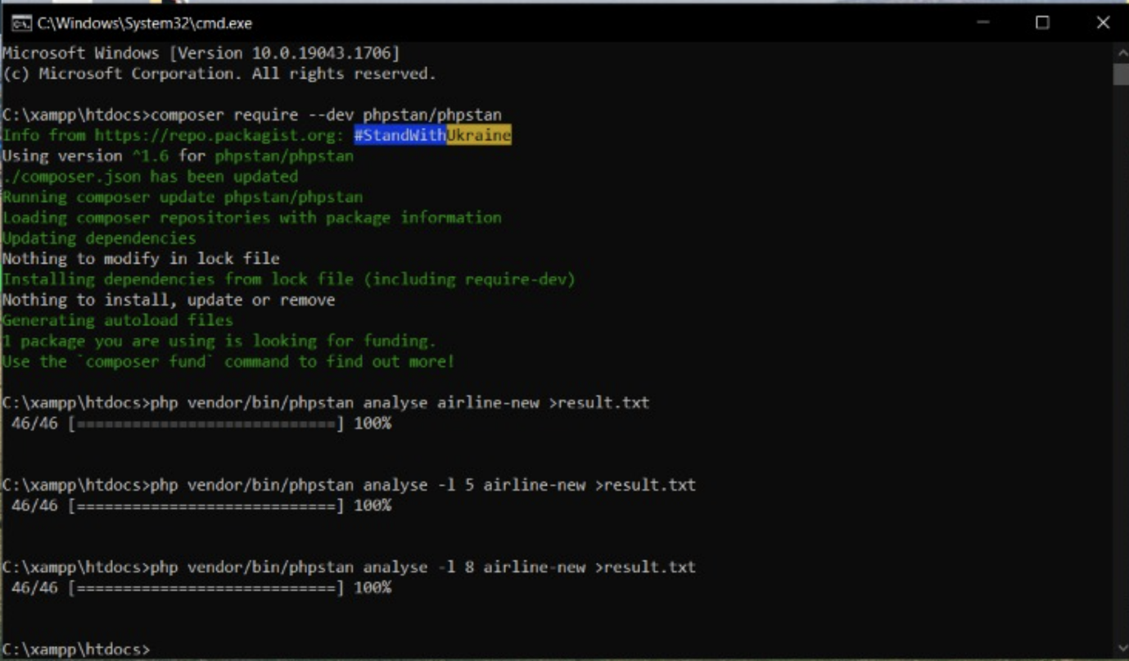

------ -------------------------------------------------------------------------------------------------------------

Line activate_jet_details_form_handler.php

------ -------------------------------------------------------------------------------------------------------------

26 Variable $dbc might not be defined.

27 Parameter #1 $statement of function mysqli_stmt_bind_param expects mysqli_stmt, mysqli_stmt|false given.

27 Variable $jet_id might not be defined.

28 Parameter #1 $statement of function mysqli_stmt_execute expects mysqli_stmt, mysqli_stmt|false given.

29 Parameter #1 $statement of function mysqli_stmt_affected_rows expects mysqli_stmt, mysqli_stmt|false given.

34 Parameter #1 $statement of function mysqli_stmt_close expects mysqli_stmt, mysqli_stmt|false given.

35 Variable $dbc might not be defined.

47 Function mysqli_error invoked with 0 parameters, 1 required.

------ -------------------------------------------------------------------------------------------------------------

------ -------------------------------------------------------------------------------------------------------------

Line add_flight_details_form_handler.php

------ -------------------------------------------------------------------------------------------------------------

122 Variable $dbc might not be defined.

123 Parameter #1 $statement of function mysqli_stmt_bind_param expects mysqli_stmt, mysqli_stmt|false given.

123 Variable $jet_id might not be defined.

124 Parameter #1 $statement of function mysqli_stmt_execute expects mysqli_stmt, mysqli_stmt|false given.

125 Parameter #1 $statement of function mysqli_stmt_bind_result expects mysqli_stmt, mysqli_stmt|false given.

126 Parameter #1 $statement of function mysqli_stmt_fetch expects mysqli_stmt, mysqli_stmt|false given.

127 Parameter #1 $statement of function mysqli_stmt_close expects mysqli_stmt, mysqli_stmt|false given.

132 Variable $dbc might not be defined.

133 Parameter #1 $statement of function mysqli_stmt_bind_param expects mysqli_stmt, mysqli_stmt|false given.

133 Variable $arr_date might not be defined.

133 Variable $arr_time might not be defined.

133 Variable $dep_date might not be defined.

133 Variable $dep_time might not be defined.

133 Variable $destination might not be defined.

133 Variable $flight_no might not be defined.

133 Variable $jet_id might not be defined.

133 Variable $origin might not be defined.

133 Variable $price_bus might not be defined.

133 Variable $price_eco might not be defined.

133 Variable $seats_bus might not be defined.

133 Variable $seats_eco might not be defined.

134 Parameter #1 $statement of function mysqli_stmt_execute expects mysqli_stmt, mysqli_stmt|false given.

135 Parameter #1 $statement of function mysqli_stmt_affected_rows expects mysqli_stmt, mysqli_stmt|false given.

136 Parameter #1 $statement of function mysqli_stmt_close expects mysqli_stmt, mysqli_stmt|false given.

142 Variable $dbc might not be defined.

151 Function mysqli_error invoked with 0 parameters, 1 required.

------ -------------------------------------------------------------------------------------------------------------

------ -------------------------------------------------------------------------------------------------------------

Line add_jet_details_form_handler.php

------ -------------------------------------------------------------------------------------------------------------

44 Variable $dbc might not be defined.

45 Parameter #1 $statement of function mysqli_stmt_bind_param expects mysqli_stmt, mysqli_stmt|false given.

45 Variable $jet_capacity might not be defined.

45 Variable $jet_id might not be defined.

45 Variable $jet_type might not be defined.

46 Parameter #1 $statement of function mysqli_stmt_execute expects mysqli_stmt, mysqli_stmt|false given.

47 Parameter #1 $statement of function mysqli_stmt_affected_rows expects mysqli_stmt, mysqli_stmt|false given.

52 Parameter #1 $statement of function mysqli_stmt_close expects mysqli_stmt, mysqli_stmt|false given.

53 Variable $dbc might not be defined.

65 Function mysqli_error invoked with 0 parameters, 1 required.

------ -------------------------------------------------------------------------------------------------------------

------ -------------------------------------------------------------------------------------------------------------

Line add_ticket_details_form_handler.php

------ -------------------------------------------------------------------------------------------------------------

38 Variable $dbc might not be defined.

39 Parameter #1 $statement of function mysqli_stmt_bind_param expects mysqli_stmt, mysqli_stmt|false given.

40 Parameter #1 $statement of function mysqli_stmt_execute expects mysqli_stmt, mysqli_stmt|false given.

41 Parameter #1 $statement of function mysqli_stmt_bind_result expects mysqli_stmt, mysqli_stmt|false given.

42 Parameter #1 $statement of function mysqli_stmt_fetch expects mysqli_stmt, mysqli_stmt|false given.

47 Variable $dbc might not be defined.

48 Parameter #1 $statement of function mysqli_stmt_bind_param expects mysqli_stmt, mysqli_stmt|false given.

49 Parameter #1 $statement of function mysqli_stmt_execute expects mysqli_stmt, mysqli_stmt|false given.

50 Parameter #1 $statement of function mysqli_stmt_bind_result expects mysqli_stmt, mysqli_stmt|false given.

51 Parameter #1 $statement of function mysqli_stmt_fetch expects mysqli_stmt, mysqli_stmt|false given.

53 Variable $stmt might not be defined.

54 Variable $ticket_price might not be defined.

57 Variable $dbc might not be defined.

58 Parameter #1 $statement of function mysqli_stmt_bind_param expects mysqli_stmt, mysqli_stmt|false given.

59 Parameter #1 $statement of function mysqli_stmt_execute expects mysqli_stmt, mysqli_stmt|false given.

60 Parameter #1 $statement of function mysqli_stmt_affected_rows expects mysqli_stmt, mysqli_stmt|false given.

75 Function mysqli_error invoked with 0 parameters, 1 required.

86 Variable $dbc might not be defined.

87 Parameter #1 $statement of function mysqli_stmt_bind_param expects mysqli_stmt, mysqli_stmt|false given.

88 Parameter #1 $statement of function mysqli_stmt_execute expects mysqli_stmt, mysqli_stmt|false given.

89 Parameter #1 $statement of function mysqli_stmt_affected_rows expects mysqli_stmt, mysqli_stmt|false given.

90 Parameter #1 $statement of function mysqli_stmt_bind_result expects mysqli_stmt, mysqli_stmt|false given.

91 Parameter #1 $statement of function mysqli_stmt_fetch expects mysqli_stmt, mysqli_stmt|false given.

93 Parameter #1 $statement of function mysqli_stmt_close expects mysqli_stmt, mysqli_stmt|false given.

98 Variable $dbc might not be defined.

99 Parameter #1 $statement of function mysqli_stmt_bind_param expects mysqli_stmt, mysqli_stmt|false given.

100 Parameter #1 $statement of function mysqli_stmt_execute expects mysqli_stmt, mysqli_stmt|false given.

101 Parameter #1 $statement of function mysqli_stmt_affected_rows expects mysqli_stmt, mysqli_stmt|false given.

103 Parameter #1 $statement of function mysqli_stmt_close expects mysqli_stmt, mysqli_stmt|false given.

108 Variable $dbc might not be defined.

112 Parameter #1 $statement of function mysqli_stmt_bind_param expects mysqli_stmt, mysqli_stmt|false given.

113 Parameter #1 $statement of function mysqli_stmt_execute expects mysqli_stmt, mysqli_stmt|false given.

114 Parameter #1 $statement of function mysqli_stmt_affected_rows expects mysqli_stmt, mysqli_stmt|false given.

121 Parameter #1 $statement of function mysqli_stmt_close expects mysqli_stmt, mysqli_stmt|false given.

122 Variable $dbc might not be defined.

------ -------------------------------------------------------------------------------------------------------------

------ ------------------------------------------------------------------------------------------------------------

Line admin_profile.php

------ ------------------------------------------------------------------------------------------------------------

57 Parameter #1 $object of function date_sub expects DateTime, DateTime|false given.

57 Parameter #2 $interval of function date_sub expects DateInterval, DateInterval|false given.

58 Parameter #1 $object of function date_format expects DateTimeInterface, DateTime|false given.

62 Parameter #1 $datetime of function strtotime expects string, int<1, max> given.

73 Variable $dbc might not be defined.

74 Parameter #1 $statement of function mysqli_stmt_execute expects mysqli_stmt, mysqli_stmt|false given.

75 Parameter #1 $statement of function mysqli_stmt_bind_result expects mysqli_stmt, mysqli_stmt|false given.

76 Parameter #1 $statement of function mysqli_stmt_store_result expects mysqli_stmt, mysqli_stmt|false given.

77 Parameter #1 $statement of function mysqli_stmt_fetch expects mysqli_stmt, mysqli_stmt|false given.

82 Parameter #1 $statement of function mysqli_stmt_close expects mysqli_stmt, mysqli_stmt|false given.

83 Variable $dbc might not be defined.

------ ------------------------------------------------------------------------------------------------------------

------ ------------------------------------------------------------------------------------------------------------

Line admin_view_booked_tickets_form_handler.php

------ ------------------------------------------------------------------------------------------------------------

75 Variable $dbc might not be defined.

76 Parameter #1 $statement of function mysqli_stmt_bind_param expects mysqli_stmt, mysqli_stmt|false given.

76 Variable $departure_date might not be defined.

76 Variable $flight_no might not be defined.

77 Parameter #1 $statement of function mysqli_stmt_execute expects mysqli_stmt, mysqli_stmt|false given.

78 Parameter #1 $statement of function mysqli_stmt_bind_result expects mysqli_stmt, mysqli_stmt|false given.

79 Parameter #1 $statement of function mysqli_stmt_store_result expects mysqli_stmt, mysqli_stmt|false given.

80 Parameter #1 $statement of function mysqli_stmt_num_rows expects mysqli_stmt, mysqli_stmt|false given.

94 Parameter #1 $statement of function mysqli_stmt_fetch expects mysqli_stmt, mysqli_stmt|false given.

106 Parameter #1 $statement of function mysqli_stmt_close expects mysqli_stmt, mysqli_stmt|false given.

107 Variable $dbc might not be defined.

------ ------------------------------------------------------------------------------------------------------------

------ -----------------------------------------------------------------------------------------------

Line book_tickets.php

------ -----------------------------------------------------------------------------------------------

95 Parameter #1 $object of function date_add expects DateTime, DateTime|false given.

95 Parameter #2 $interval of function date_add expects DateInterval, DateInterval|false given.

96 Parameter #1 $object of function date_format expects DateTimeInterface, DateTime|false given.

------ -----------------------------------------------------------------------------------------------

------ -------------------------------------------------------------------------------------------------------------

Line cancel_booked_tickets_form_handler.php

------ -------------------------------------------------------------------------------------------------------------

32 Variable $dbc might not be defined.

33 Parameter #1 $statement of function mysqli_stmt_bind_param expects mysqli_stmt, mysqli_stmt|false given.

33 Variable $pnr might not be defined.

34 Parameter #1 $statement of function mysqli_stmt_execute expects mysqli_stmt, mysqli_stmt|false given.

35 Parameter #1 $statement of function mysqli_stmt_bind_result expects mysqli_stmt, mysqli_stmt|false given.

36 Parameter #1 $statement of function mysqli_stmt_fetch expects mysqli_stmt, mysqli_stmt|false given.

37 Parameter #1 $statement of function mysqli_stmt_close expects mysqli_stmt, mysqli_stmt|false given.

40 Variable $dbc might not be defined.

44 Variable $dbc might not be defined.

45 Parameter #1 $statement of function mysqli_stmt_bind_param expects mysqli_stmt, mysqli_stmt|false given.

45 Variable $pnr might not be defined.

46 Parameter #1 $statement of function mysqli_stmt_execute expects mysqli_stmt, mysqli_stmt|false given.

47 Parameter #1 $statement of function mysqli_stmt_affected_rows expects mysqli_stmt, mysqli_stmt|false given.

52 Parameter #1 $statement of function mysqli_stmt_close expects mysqli_stmt, mysqli_stmt|false given.

56 Variable $dbc might not be defined.

57 Parameter #1 $statement of function mysqli_stmt_bind_param expects mysqli_stmt, mysqli_stmt|false given.

57 Variable $pnr might not be defined.

58 Parameter #1 $statement of function mysqli_stmt_execute expects mysqli_stmt, mysqli_stmt|false given.

59 Parameter #1 $statement of function mysqli_stmt_bind_result expects mysqli_stmt, mysqli_stmt|false given.

60 Parameter #1 $statement of function mysqli_stmt_fetch expects mysqli_stmt, mysqli_stmt|false given.

61 Parameter #1 $statement of function mysqli_stmt_close expects mysqli_stmt, mysqli_stmt|false given.

66 Variable $dbc might not be defined.

67 Parameter #1 $statement of function mysqli_stmt_bind_param expects mysqli_stmt, mysqli_stmt|false given.

68 Parameter #1 $statement of function mysqli_stmt_execute expects mysqli_stmt, mysqli_stmt|false given.

69 Parameter #1 $statement of function mysqli_stmt_affected_rows expects mysqli_stmt, mysqli_stmt|false given.

71 Parameter #1 $statement of function mysqli_stmt_close expects mysqli_stmt, mysqli_stmt|false given.

76 Variable $dbc might not be defined.

77 Parameter #1 $statement of function mysqli_stmt_bind_param expects mysqli_stmt, mysqli_stmt|false given.

78 Parameter #1 $statement of function mysqli_stmt_execute expects mysqli_stmt, mysqli_stmt|false given.

79 Parameter #1 $statement of function mysqli_stmt_affected_rows expects mysqli_stmt, mysqli_stmt|false given.

81 Parameter #1 $statement of function mysqli_stmt_close expects mysqli_stmt, mysqli_stmt|false given.

83 Variable $affected_rows_1 might not be defined.

91 Function mysqli_error invoked with 0 parameters, 1 required.

97 Function mysqli_error invoked with 0 parameters, 1 required.

100 Variable $dbc might not be defined.

------ -------------------------------------------------------------------------------------------------------------

------ ------------------------------------------------------------------------------------------------------

Line css\password-reset-token.php

------ ------------------------------------------------------------------------------------------------------

8 Variable $dbc might not be defined.

10 Parameter #1 $result of function mysqli_fetch_array expects mysqli_result, bool|mysqli_result given.

18 Parameter #1 $hour of function mktime expects int, string given.

18 Parameter #2 $minute of function mktime expects int|null, string given.

18 Parameter #3 $second of function mktime expects int|null, string given.

18 Parameter #4 $month of function mktime expects int|null, string given.

18 Parameter #6 $year of function mktime expects int|null, string given.

21 Parameter #2 $timestamp of function date expects int|null, int|false given.

23 Variable $dbc might not be defined.

23 Variable $password might not be defined.

29 Instantiated class PHPMailer not found.

💡 Learn more at https://phpstan.org/user-guide/discovering-symbols

31 Access to property $CharSet on an unknown class PHPMailer.

💡 Learn more at https://phpstan.org/user-guide/discovering-symbols

31 Access to property $CharSet on an unknown class PHPMailer.

💡 Learn more at https://phpstan.org/user-guide/discovering-symbols

32 Call to method IsSMTP() on an unknown class PHPMailer.

💡 Learn more at https://phpstan.org/user-guide/discovering-symbols

34 Access to property $SMTPAuth on an unknown class PHPMailer.

💡 Learn more at https://phpstan.org/user-guide/discovering-symbols

34 Access to property $SMTPAuth on an unknown class PHPMailer.

💡 Learn more at https://phpstan.org/user-guide/discovering-symbols

36 Access to property $Username on an unknown class PHPMailer.

💡 Learn more at https://phpstan.org/user-guide/discovering-symbols

36 Access to property $Username on an unknown class PHPMailer.

💡 Learn more at https://phpstan.org/user-guide/discovering-symbols

38 Access to property $Password on an unknown class PHPMailer.

💡 Learn more at https://phpstan.org/user-guide/discovering-symbols

38 Access to property $Password on an unknown class PHPMailer.

💡 Learn more at https://phpstan.org/user-guide/discovering-symbols

39 Access to property $SMTPSecure on an unknown class PHPMailer.

💡 Learn more at https://phpstan.org/user-guide/discovering-symbols

39 Access to property $SMTPSecure on an unknown class PHPMailer.

💡 Learn more at https://phpstan.org/user-guide/discovering-symbols

41 Access to property $Host on an unknown class PHPMailer.

💡 Learn more at https://phpstan.org/user-guide/discovering-symbols

41 Access to property $Host on an unknown class PHPMailer.

💡 Learn more at https://phpstan.org/user-guide/discovering-symbols

43 Access to property $Port on an unknown class PHPMailer.

💡 Learn more at https://phpstan.org/user-guide/discovering-symbols

43 Access to property $Port on an unknown class PHPMailer.

💡 Learn more at https://phpstan.org/user-guide/discovering-symbols

44 Access to property $From on an unknown class PHPMailer.

💡 Learn more at https://phpstan.org/user-guide/discovering-symbols

44 Access to property $From on an unknown class PHPMailer.

💡 Learn more at https://phpstan.org/user-guide/discovering-symbols

45 Access to property $FromName on an unknown class PHPMailer.

💡 Learn more at https://phpstan.org/user-guide/discovering-symbols

45 Access to property $FromName on an unknown class PHPMailer.

💡 Learn more at https://phpstan.org/user-guide/discovering-symbols

46 Call to method AddAddress() on an unknown class PHPMailer.

💡 Learn more at https://phpstan.org/user-guide/discovering-symbols

47 Access to property $Subject on an unknown class PHPMailer.

💡 Learn more at https://phpstan.org/user-guide/discovering-symbols

47 Access to property $Subject on an unknown class PHPMailer.

💡 Learn more at https://phpstan.org/user-guide/discovering-symbols

48 Call to method IsHTML() on an unknown class PHPMailer.

💡 Learn more at https://phpstan.org/user-guide/discovering-symbols

49 Access to property $Body on an unknown class PHPMailer.

💡 Learn more at https://phpstan.org/user-guide/discovering-symbols

49 Access to property $Body on an unknown class PHPMailer.

💡 Learn more at https://phpstan.org/user-guide/discovering-symbols

50 Call to method Send() on an unknown class PHPMailer.

💡 Learn more at https://phpstan.org/user-guide/discovering-symbols

56 Access to property $ErrorInfo on an unknown class PHPMailer.

💡 Learn more at https://phpstan.org/user-guide/discovering-symbols

------ ------------------------------------------------------------------------------------------------------

------ ------------------------------------------------------------------------------------------------------------

Line cust_profile.php

------ ------------------------------------------------------------------------------------------------------------

62 Parameter #1 $object of function date_sub expects DateTime, DateTime|false given.

62 Parameter #2 $interval of function date_sub expects DateInterval, DateInterval|false given.

63 Parameter #1 $object of function date_format expects DateTimeInterface, DateTime|false given.

67 Parameter #1 $datetime of function strtotime expects string, int<1, max> given.

79 Variable $dbc might not be defined.

80 Parameter #1 $statement of function mysqli_stmt_bind_param expects mysqli_stmt, mysqli_stmt|false given.

81 Parameter #1 $statement of function mysqli_stmt_execute expects mysqli_stmt, mysqli_stmt|false given.

82 Parameter #1 $statement of function mysqli_stmt_bind_result expects mysqli_stmt, mysqli_stmt|false given.

83 Parameter #1 $statement of function mysqli_stmt_store_result expects mysqli_stmt, mysqli_stmt|false given.

84 Parameter #1 $statement of function mysqli_stmt_fetch expects mysqli_stmt, mysqli_stmt|false given.

92 Parameter #1 $statement of function mysqli_stmt_close expects mysqli_stmt, mysqli_stmt|false given.

93 Variable $dbc might not be defined.

------ ------------------------------------------------------------------------------------------------------------

------ -----------------------------------------------------------------------------------------------------------

Line customer_homepage.php

------ -----------------------------------------------------------------------------------------------------------

62 Variable $dbc might not be defined.

63 Parameter #1 $statement of function mysqli_stmt_bind_param expects mysqli_stmt, mysqli_stmt|false given.

64 Parameter #1 $statement of function mysqli_stmt_execute expects mysqli_stmt, mysqli_stmt|false given.

65 Parameter #1 $statement of function mysqli_stmt_bind_result expects mysqli_stmt, mysqli_stmt|false given.

66 Parameter #1 $statement of function mysqli_stmt_fetch expects mysqli_stmt, mysqli_stmt|false given.

71 Parameter #1 $statement of function mysqli_stmt_close expects mysqli_stmt, mysqli_stmt|false given.

72 Variable $dbc might not be defined.

------ -----------------------------------------------------------------------------------------------------------

------ -------------------------------------------------------------------------------------------------------------

Line deactivate_jet_details_form_handler.php

------ -------------------------------------------------------------------------------------------------------------

26 Variable $dbc might not be defined.

27 Parameter #1 $statement of function mysqli_stmt_bind_param expects mysqli_stmt, mysqli_stmt|false given.

27 Variable $jet_id might not be defined.

28 Parameter #1 $statement of function mysqli_stmt_execute expects mysqli_stmt, mysqli_stmt|false given.

29 Parameter #1 $statement of function mysqli_stmt_affected_rows expects mysqli_stmt, mysqli_stmt|false given.

34 Parameter #1 $statement of function mysqli_stmt_close expects mysqli_stmt, mysqli_stmt|false given.

35 Variable $dbc might not be defined.

47 Function mysqli_error invoked with 0 parameters, 1 required.

------ -------------------------------------------------------------------------------------------------------------

------ -------------------------------------------------------------------------------------------------------------

Line delete_flight_details_form_handler.php

------ -------------------------------------------------------------------------------------------------------------

34 Variable $dbc might not be defined.

35 Parameter #1 $statement of function mysqli_stmt_bind_param expects mysqli_stmt, mysqli_stmt|false given.

35 Variable $departure_date might not be defined.

35 Variable $flight_no might not be defined.

36 Parameter #1 $statement of function mysqli_stmt_execute expects mysqli_stmt, mysqli_stmt|false given.

37 Parameter #1 $statement of function mysqli_stmt_affected_rows expects mysqli_stmt, mysqli_stmt|false given.

42 Parameter #1 $statement of function mysqli_stmt_close expects mysqli_stmt, mysqli_stmt|false given.

43 Variable $dbc might not be defined.

55 Function mysqli_error invoked with 0 parameters, 1 required.

------ -------------------------------------------------------------------------------------------------------------

------ -------------------------------------------------------------------------------------------------------------

Line edit_admin_profile_form_handler.php

------ -------------------------------------------------------------------------------------------------------------

37 Variable $dbc might not be defined.

38 Parameter #1 $statement of function mysqli_stmt_bind_param expects mysqli_stmt, mysqli_stmt|false given.

38 Variable $email might not be defined.

38 Variable $name might not be defined.

39 Parameter #1 $statement of function mysqli_stmt_execute expects mysqli_stmt, mysqli_stmt|false given.

40 Parameter #1 $statement of function mysqli_stmt_affected_rows expects mysqli_stmt, mysqli_stmt|false given.

45 Parameter #1 $statement of function mysqli_stmt_close expects mysqli_stmt, mysqli_stmt|false given.

46 Variable $dbc might not be defined.

58 Function mysqli_error invoked with 0 parameters, 1 required.

------ -------------------------------------------------------------------------------------------------------------

------ -------------------------------------------------------------------------------------------------------------

Line edit_cust_profile_form_handler.php

------ -------------------------------------------------------------------------------------------------------------

37 Variable $dbc might not be defined.

38 Parameter #1 $statement of function mysqli_stmt_bind_param expects mysqli_stmt, mysqli_stmt|false given.

38 Variable $email might not be defined.

38 Variable $name might not be defined.

39 Parameter #1 $statement of function mysqli_stmt_execute expects mysqli_stmt, mysqli_stmt|false given.

40 Parameter #1 $statement of function mysqli_stmt_affected_rows expects mysqli_stmt, mysqli_stmt|false given.

45 Parameter #1 $statement of function mysqli_stmt_close expects mysqli_stmt, mysqli_stmt|false given.

46 Variable $dbc might not be defined.

58 Function mysqli_error invoked with 0 parameters, 1 required.

------ -------------------------------------------------------------------------------------------------------------

------ -----------------------------------------------------------------------------------------------------------

Line login_handler.php

------ -----------------------------------------------------------------------------------------------------------

42 Variable $user_type might not be defined.

46 Variable $dbc might not be defined.

47 Parameter #1 $statement of function mysqli_stmt_bind_param expects mysqli_stmt, mysqli_stmt|false given.

47 Variable $pass_word might not be defined.

47 Variable $user_name might not be defined.

48 Parameter #1 $statement of function mysqli_stmt_execute expects mysqli_stmt, mysqli_stmt|false given.

49 Parameter #1 $statement of function mysqli_stmt_bind_result expects mysqli_stmt, mysqli_stmt|false given.

50 Parameter #1 $statement of function mysqli_stmt_fetch expects mysqli_stmt, mysqli_stmt|false given.

52 Parameter #1 $statement of function mysqli_stmt_close expects mysqli_stmt, mysqli_stmt|false given.

53 Variable $dbc might not be defined.

61 Variable $user_name might not be defined.

72 Variable $user_type might not be defined.

76 Variable $dbc might not be defined.

77 Parameter #1 $statement of function mysqli_stmt_bind_param expects mysqli_stmt, mysqli_stmt|false given.

77 Variable $pass_word might not be defined.

77 Variable $user_name might not be defined.

78 Parameter #1 $statement of function mysqli_stmt_execute expects mysqli_stmt, mysqli_stmt|false given.

79 Parameter #1 $statement of function mysqli_stmt_bind_result expects mysqli_stmt, mysqli_stmt|false given.

80 Parameter #1 $statement of function mysqli_stmt_fetch expects mysqli_stmt, mysqli_stmt|false given.

82 Parameter #1 $statement of function mysqli_stmt_close expects mysqli_stmt, mysqli_stmt|false given.

83 Variable $dbc might not be defined.

91 Variable $user_name might not be defined.

------ -----------------------------------------------------------------------------------------------------------

------ -------------------------------------------------------------------------------------------------------------

Line new_user_form_handler.php

------ -------------------------------------------------------------------------------------------------------------

68 Variable $dbc might not be defined.

69 Parameter #1 $statement of function mysqli_stmt_bind_param expects mysqli_stmt, mysqli_stmt|false given.

69 Variable $address might not be defined.

69 Variable $email_id might not be defined.

69 Variable $membership might not be defined.

69 Variable $name might not be defined.

69 Variable $password might not be defined.

69 Variable $phone_no might not be defined.

69 Variable $user_name might not be defined.

70 Parameter #1 $statement of function mysqli_stmt_execute expects mysqli_stmt, mysqli_stmt|false given.

71 Parameter #1 $statement of function mysqli_stmt_affected_rows expects mysqli_stmt, mysqli_stmt|false given.

76 Parameter #1 $statement of function mysqli_stmt_close expects mysqli_stmt, mysqli_stmt|false given.

77 Variable $dbc might not be defined.

88 Function mysqli_error invoked with 0 parameters, 1 required.

------ -------------------------------------------------------------------------------------------------------------

------ -----------------------------------------------------------------------------------------------------------

Line payment_details.php

------ -----------------------------------------------------------------------------------------------------------

63 Variable $dbc might not be defined.

64 Parameter #1 $statement of function mysqli_stmt_bind_param expects mysqli_stmt, mysqli_stmt|false given.

65 Parameter #1 $statement of function mysqli_stmt_execute expects mysqli_stmt, mysqli_stmt|false given.

66 Parameter #1 $statement of function mysqli_stmt_bind_result expects mysqli_stmt, mysqli_stmt|false given.

67 Parameter #1 $statement of function mysqli_stmt_fetch expects mysqli_stmt, mysqli_stmt|false given.

72 Variable $dbc might not be defined.

73 Parameter #1 $statement of function mysqli_stmt_bind_param expects mysqli_stmt, mysqli_stmt|false given.

74 Parameter #1 $statement of function mysqli_stmt_execute expects mysqli_stmt, mysqli_stmt|false given.

75 Parameter #1 $statement of function mysqli_stmt_bind_result expects mysqli_stmt, mysqli_stmt|false given.

76 Parameter #1 $statement of function mysqli_stmt_fetch expects mysqli_stmt, mysqli_stmt|false given.

78 Variable $stmt might not be defined.

79 Variable $dbc might not be defined.

80 Variable $ticket_price might not be defined.

------ -----------------------------------------------------------------------------------------------------------

------ -------------------------------------------------------------------------------------------------------------

Line payment_details_form_handler.php

------ -------------------------------------------------------------------------------------------------------------

26 Variable $dbc might not be defined.

27 Parameter #1 $statement of function mysqli_stmt_bind_param expects mysqli_stmt, mysqli_stmt|false given.

28 Parameter #1 $statement of function mysqli_stmt_execute expects mysqli_stmt, mysqli_stmt|false given.

29 Parameter #1 $statement of function mysqli_stmt_affected_rows expects mysqli_stmt, mysqli_stmt|false given.

31 Parameter #1 $statement of function mysqli_stmt_close expects mysqli_stmt, mysqli_stmt|false given.

36 Variable $dbc might not be defined.

37 Parameter #1 $statement of function mysqli_stmt_bind_param expects mysqli_stmt, mysqli_stmt|false given.

38 Parameter #1 $statement of function mysqli_stmt_execute expects mysqli_stmt, mysqli_stmt|false given.

39 Parameter #1 $statement of function mysqli_stmt_affected_rows expects mysqli_stmt, mysqli_stmt|false given.

41 Parameter #1 $statement of function mysqli_stmt_close expects mysqli_stmt, mysqli_stmt|false given.

49 Variable $affected_rows_1 might not be defined.

54 Variable $dbc might not be defined.

55 Parameter #1 $statement of function mysqli_stmt_bind_param expects mysqli_stmt, mysqli_stmt|false given.

56 Parameter #1 $statement of function mysqli_stmt_execute expects mysqli_stmt, mysqli_stmt|false given.

57 Parameter #1 $statement of function mysqli_stmt_affected_rows expects mysqli_stmt, mysqli_stmt|false given.

59 Parameter #1 $statement of function mysqli_stmt_close expects mysqli_stmt, mysqli_stmt|false given.

68 Function mysqli_error invoked with 0 parameters, 1 required.

74 Function mysqli_error invoked with 0 parameters, 1 required.

76 Variable $dbc might not be defined.

------ -------------------------------------------------------------------------------------------------------------

------ ------------------------------------------------------------------------------------------------------------

Line ticket.php

------ ------------------------------------------------------------------------------------------------------------

77 Variable $dbc might not be defined.

78 Parameter #1 $statement of function mysqli_stmt_bind_param expects mysqli_stmt, mysqli_stmt|false given.

78 Variable $pnr might not be defined.

79 Parameter #1 $statement of function mysqli_stmt_execute expects mysqli_stmt, mysqli_stmt|false given.

80 Parameter #1 $statement of function mysqli_stmt_bind_result expects mysqli_stmt, mysqli_stmt|false given.

81 Parameter #1 $statement of function mysqli_stmt_store_result expects mysqli_stmt, mysqli_stmt|false given.

82 Parameter #1 $statement of function mysqli_stmt_fetch expects mysqli_stmt, mysqli_stmt|false given.

91 Parameter #1 $statement of function mysqli_stmt_close expects mysqli_stmt, mysqli_stmt|false given.

92 Variable $dbc might not be defined.

------ ------------------------------------------------------------------------------------------------------------

------ -------------------------------------

Line upload_documents_form_handler.php

------ -------------------------------------

70 Variable $dbc might not be defined.

------ -------------------------------------

------ ------------------------------------------------------------------------------------------------------------

Line view_booked_tickets.php

------ ------------------------------------------------------------------------------------------------------------

61 Parameter #1 $object of function date_sub expects DateTime, DateTime|false given.

61 Parameter #2 $interval of function date_sub expects DateInterval, DateInterval|false given.

62 Parameter #1 $object of function date_format expects DateTimeInterface, DateTime|false given.

67 Variable $dbc might not be defined.

68 Parameter #1 $statement of function mysqli_stmt_bind_param expects mysqli_stmt, mysqli_stmt|false given.

69 Parameter #1 $statement of function mysqli_stmt_execute expects mysqli_stmt, mysqli_stmt|false given.

70 Parameter #1 $statement of function mysqli_stmt_bind_result expects mysqli_stmt, mysqli_stmt|false given.

71 Parameter #1 $statement of function mysqli_stmt_store_result expects mysqli_stmt, mysqli_stmt|false given.

72 Parameter #1 $statement of function mysqli_stmt_num_rows expects mysqli_stmt, mysqli_stmt|false given.

88 Parameter #1 $statement of function mysqli_stmt_fetch expects mysqli_stmt, mysqli_stmt|false given.

107 Variable $dbc might not be defined.

108 Parameter #1 $statement of function mysqli_stmt_bind_param expects mysqli_stmt, mysqli_stmt|false given.

109 Parameter #1 $statement of function mysqli_stmt_execute expects mysqli_stmt, mysqli_stmt|false given.

110 Parameter #1 $statement of function mysqli_stmt_bind_result expects mysqli_stmt, mysqli_stmt|false given.

111 Parameter #1 $statement of function mysqli_stmt_store_result expects mysqli_stmt, mysqli_stmt|false given.

112 Parameter #1 $statement of function mysqli_stmt_num_rows expects mysqli_stmt, mysqli_stmt|false given.

123 Variable $dbc might not be defined.

124 Parameter #1 $statement of function mysqli_stmt_bind_param expects mysqli_stmt, mysqli_stmt|false given.

125 Parameter #1 $statement of function mysqli_stmt_execute expects mysqli_stmt, mysqli_stmt|false given.

126 Parameter #1 $statement of function mysqli_stmt_bind_result expects mysqli_stmt, mysqli_stmt|false given.

127 Parameter #1 $statement of function mysqli_stmt_store_result expects mysqli_stmt, mysqli_stmt|false given.

128 Parameter #1 $statement of function mysqli_stmt_num_rows expects mysqli_stmt, mysqli_stmt|false given.

144 Parameter #1 $statement of function mysqli_stmt_fetch expects mysqli_stmt, mysqli_stmt|false given.

158 Parameter #1 $statement of function mysqli_stmt_close expects mysqli_stmt, mysqli_stmt|false given.

159 Variable $dbc might not be defined.

------ ------------------------------------------------------------------------------------------------------------

------ ------------------------------------------------------------------------------------------------------------

Line view_flights_form_handler.php

------ ------------------------------------------------------------------------------------------------------------

100 Variable $no_of_pass might not be defined.

101 Variable $class might not be defined.

104 Variable $dep_date might not be defined.

106 Variable $class might not be defined.

109 Variable $dbc might not be defined.

110 Parameter #1 $statement of function mysqli_stmt_bind_param expects mysqli_stmt, mysqli_stmt|false given.

110 Variable $dep_date might not be defined.

110 Variable $destination might not be defined.

110 Variable $no_of_pass might not be defined.

110 Variable $origin might not be defined.

111 Parameter #1 $statement of function mysqli_stmt_execute expects mysqli_stmt, mysqli_stmt|false given.

112 Parameter #1 $statement of function mysqli_stmt_bind_result expects mysqli_stmt, mysqli_stmt|false given.

113 Parameter #1 $statement of function mysqli_stmt_store_result expects mysqli_stmt, mysqli_stmt|false given.

114 Parameter #1 $statement of function mysqli_stmt_num_rows expects mysqli_stmt, mysqli_stmt|false given.

132 Parameter #1 $statement of function mysqli_stmt_fetch expects mysqli_stmt, mysqli_stmt|false given.

150 If condition is always true.

153 Variable $dbc might not be defined.

154 Parameter #1 $statement of function mysqli_stmt_bind_param expects mysqli_stmt, mysqli_stmt|false given.

154 Variable $dep_date might not be defined.

154 Variable $destination might not be defined.

154 Variable $no_of_pass might not be defined.

154 Variable $origin might not be defined.

155 Parameter #1 $statement of function mysqli_stmt_execute expects mysqli_stmt, mysqli_stmt|false given.

156 Parameter #1 $statement of function mysqli_stmt_bind_result expects mysqli_stmt, mysqli_stmt|false given.

157 Parameter #1 $statement of function mysqli_stmt_store_result expects mysqli_stmt, mysqli_stmt|false given.

158 Parameter #1 $statement of function mysqli_stmt_num_rows expects mysqli_stmt, mysqli_stmt|false given.

176 Parameter #1 $statement of function mysqli_stmt_fetch expects mysqli_stmt, mysqli_stmt|false given.

194 Parameter #1 $statement of function mysqli_stmt_close expects mysqli_stmt, mysqli_stmt|false given.

195 Variable $dbc might not be defined.

------ ------------------------------------------------------------------------------------------------------------

[ERROR] Found 363 errors

**8.2Unit Testing**

**8.2.1Tool used and its setup details**

We used phpunit as a tool for testing thebackend integrity of the project. 3 functions have been tested with 3 test cases each.

**8.2.2Test cases statistics**

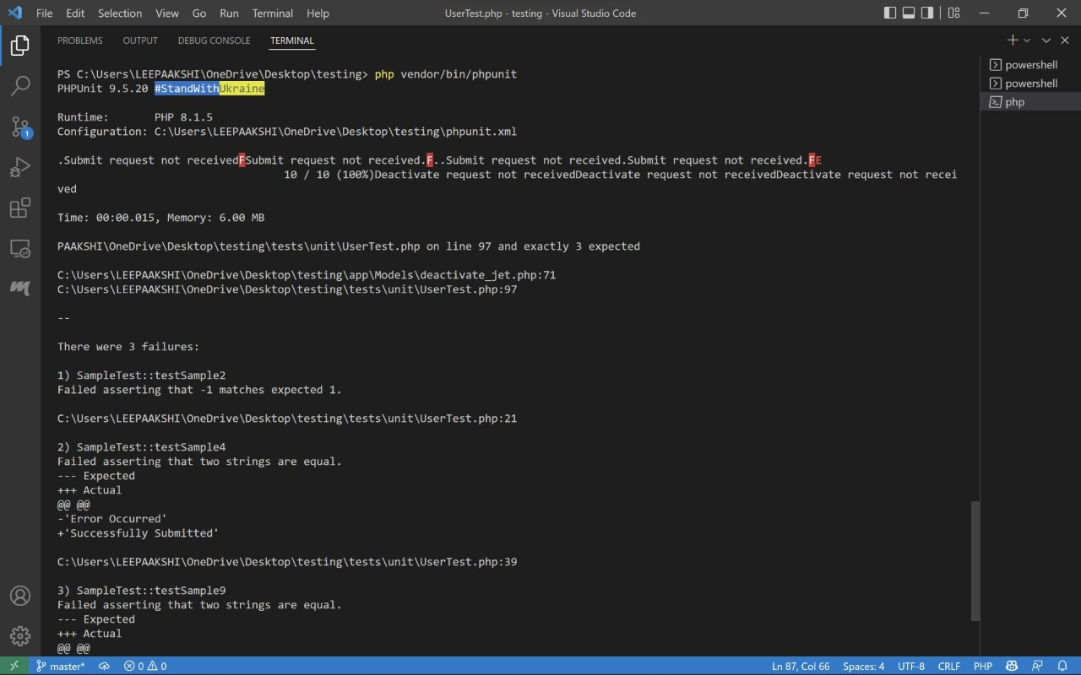

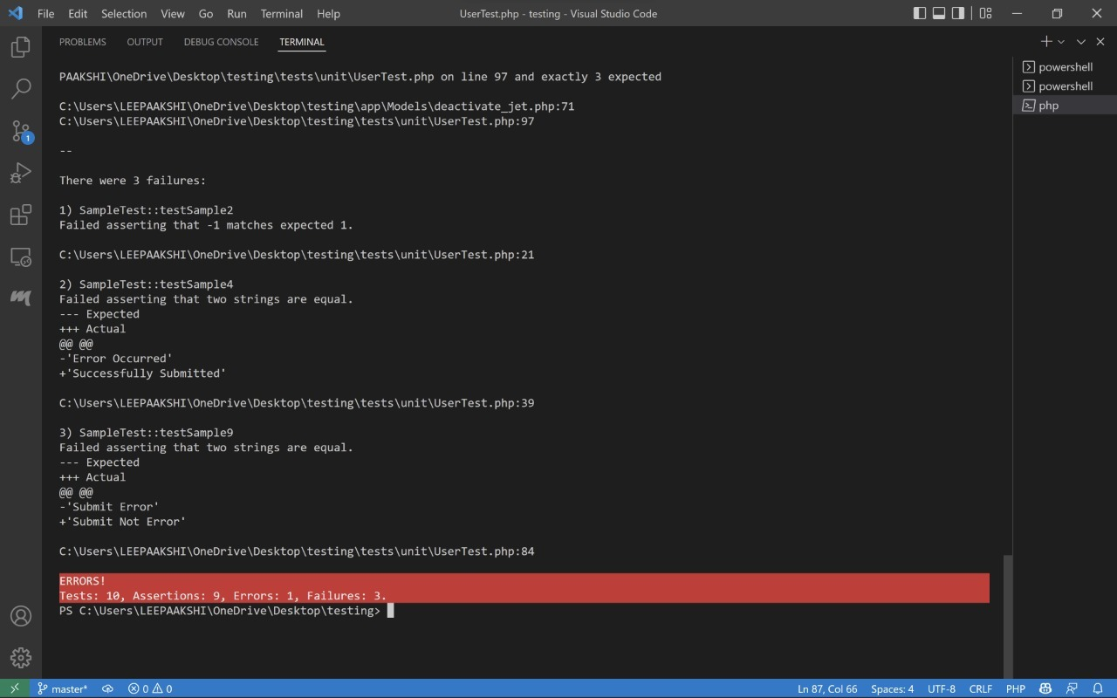

**8.2.3 Test cases code**

<?php

class SampleTest extends \PHPUnit\Framework\TestCase

{

    public function testSample() //passed in function addflight to test affected rows

    {

       $affected_rows = new \App\Models\addflight;

       $affected_rows -> addFlightDetails(1);

       $this -> assertEquals($affected_rows -> get_affected(), 1);

    }

    public function testSample2() //failed in function addflight to test affected rows

    {

       $affected_rows = new \App\Models\addflight;

       $affected_rows -> addFlightDetails(1);

       $this -> assertEquals($affected_rows -> get_affected(), -1);

    }

    public function testSample3() //passed in function addflight to test if strings are perfect

    {

       $tempstr = new \App\Models\addflight;

       $tempstr -> chk_submit("Successfully Submitted");

        $this -> assertEquals($tempstr -> get_chk_submit(), "Successfully Submitted");

    }

    public function testSample4() //failed in function addflight to test if strings are perfect

    {

       $tempstr = new \App\Models\addflight;

       $tempstr -> chk_submit("Error Occurred");

        $this -> assertEquals($tempstr -> get_chk_submit(), "Successfully Submitted");

    }

    public function testSample5() //passed in function addflight to test if strings are perfect

    {

       $tempstr = new \App\Models\addflight;

       $tempstr -> chk_submit("Error Occurred");

        $this -> assertEquals($tempstr -> get_chk_submit(), "Error Occurred");

    }

    public function testSample6() //passed in function newuser to test if passed string is empty

    {

        $query = new \App\Models\newuser;

        $query -> add_new_user("");

        $this -> assertEmpty($query -> get_new_user());

    }

    public function testSample7() //passed in function newuser to test if passed string is empty(different in the handler code)

    {

        $query = new \App\Models\newuser;

        $query -> add_new_user("this is not empty");

        $this -> assertEmpty($query -> get_new_user());

    }

    public function testSample8() //passed in function newuser to test if passed string is empty

    {

        $tempstrnew = new \App\Models\newuser;

        $tempstrnew -> chk_error("Submit Error");

        $this -> assertEquals($tempstrnew -> get_chk_error(), "Submit Error");

    }

    public function testSample9() //failed in function newuser to test if passed string is equal but passes as given in driver code

    {

        $tempstrnew = new \App\Models\newuser;

        $tempstrnew -> chk_error("Submit Error");

        $this -> assertEquals($tempstrnew -> get_chk_error(), "Submit Not Error");

    }

    public function testSample10() //error in the test case code.

    {

        $affected_rows = new \App\Models\deactivate_jet;

        $tempstrthis = new \App\Models\deactivate_jet;

        $tempstrthat = new \App\Models\deactivate_jet;

        $affected_rows -> deactivateflight(1);

        $tempstrthis -> deactivateflight("Successfully Deactivated");

        $tempstrthat -> deactivateflight("Submit Error");

        $affected_rows -> checkforTest(1);

        $tempstrthis -> checkforTest("Successfully Deactivated");

        $tempstrthat -> checkforTest("Submit Error");

        $this -> assertEquals($affected_rows -> get_affected(), 1);

    }

}

**8.3 – UI Testing Report**

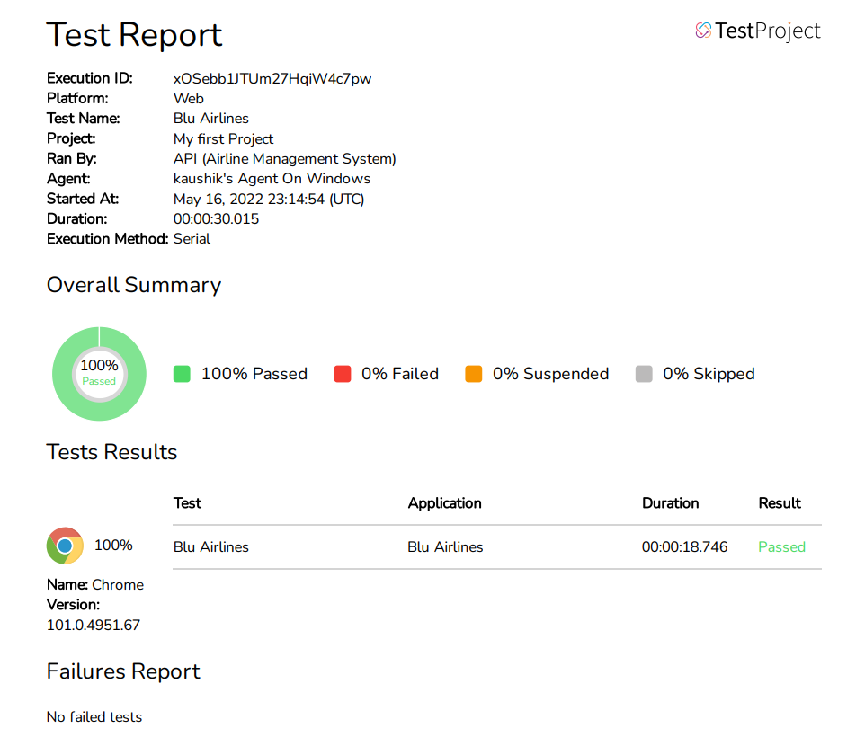

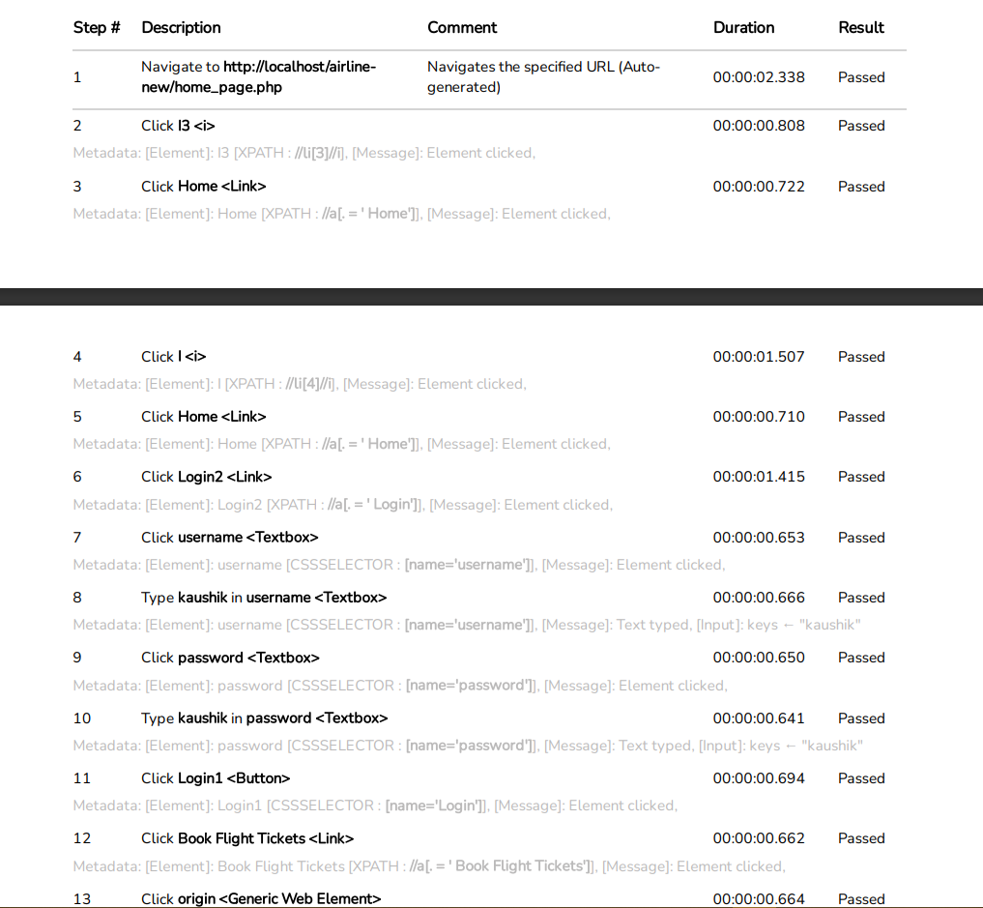

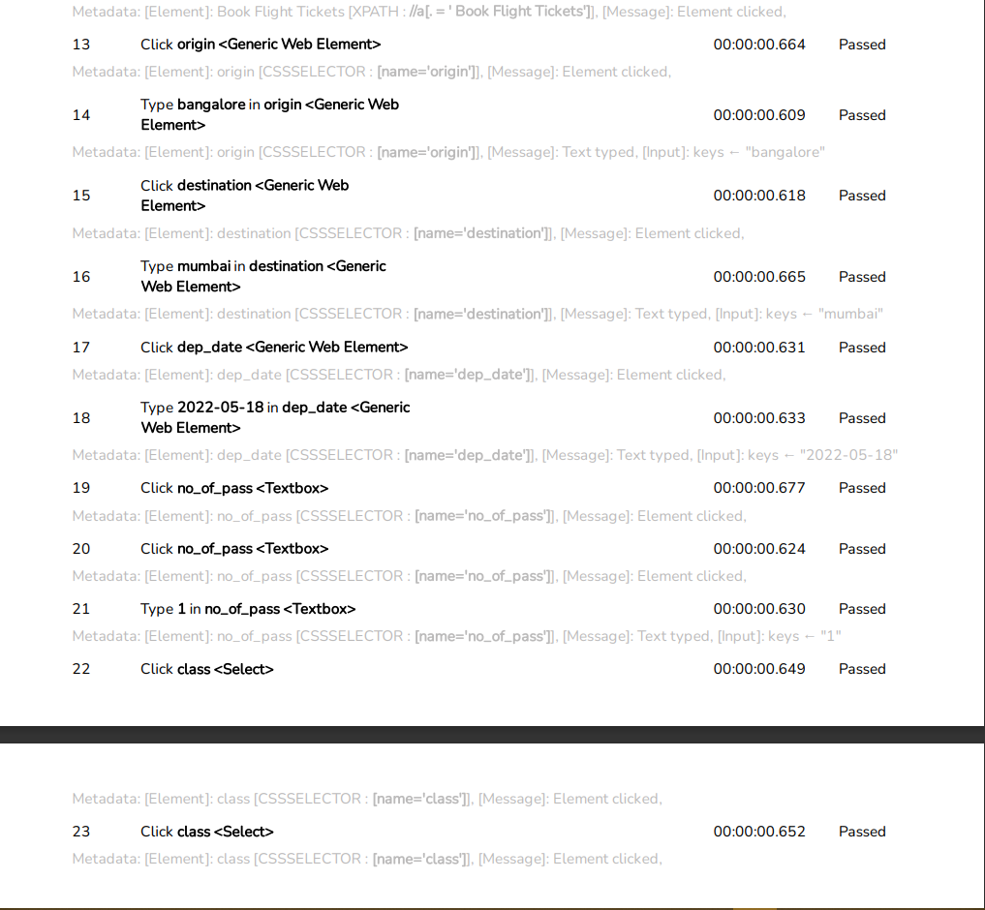

**8.4 – Integration Testing**

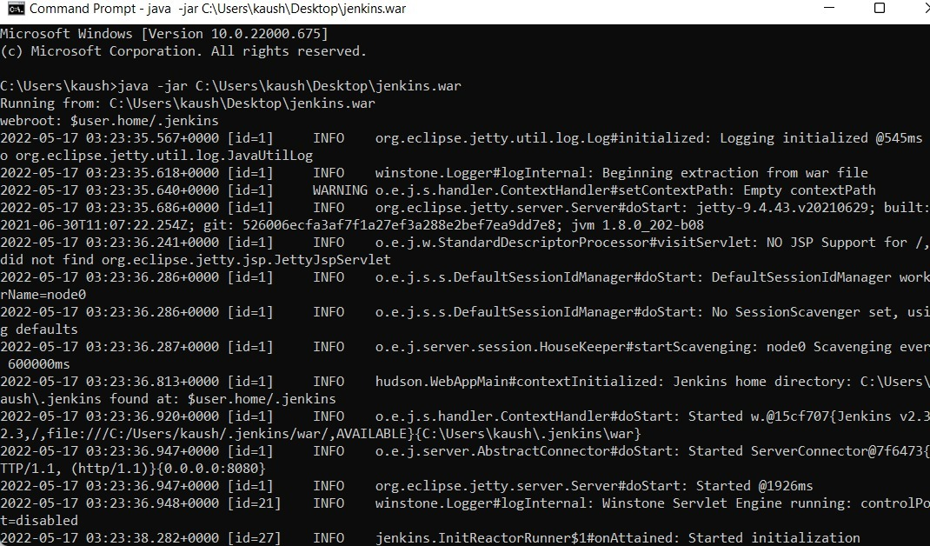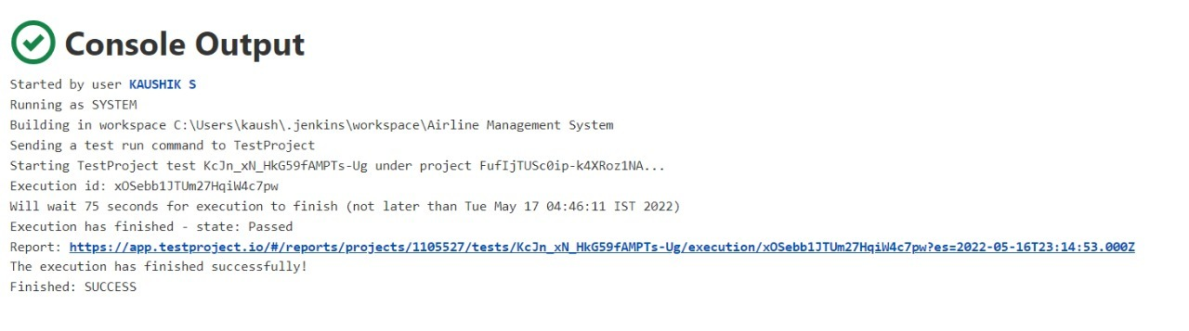

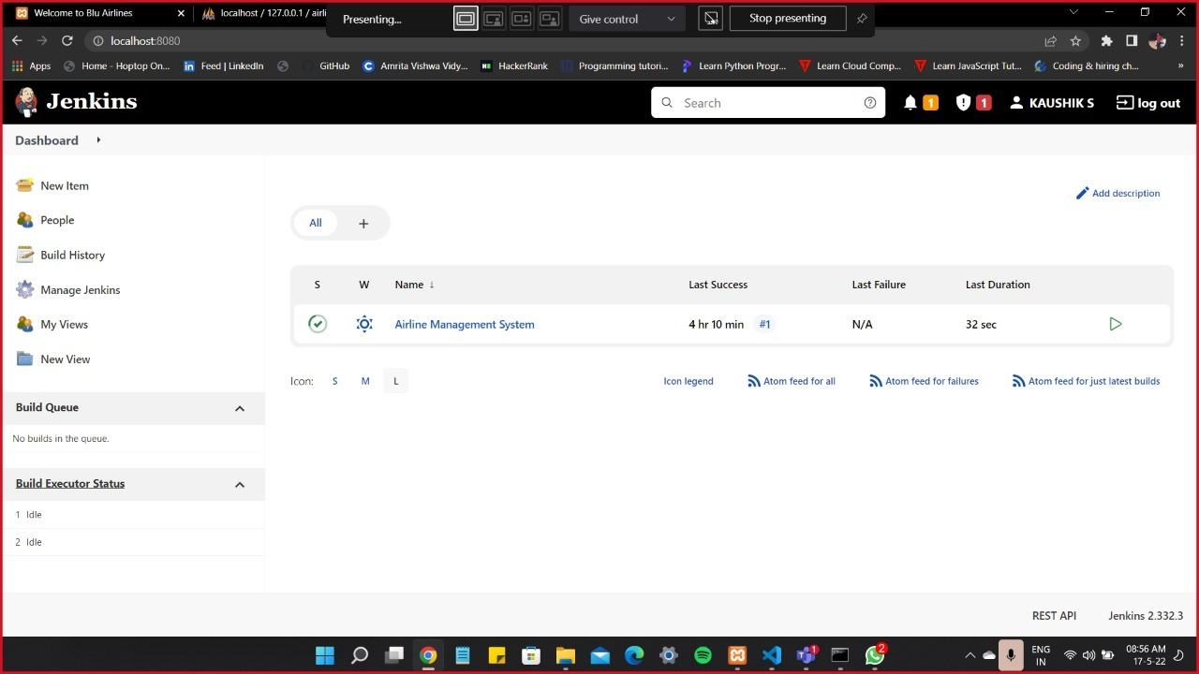

**9. Screenshots:**

**Done in sprint1:**

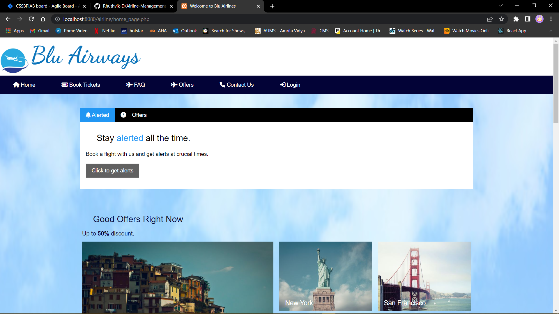

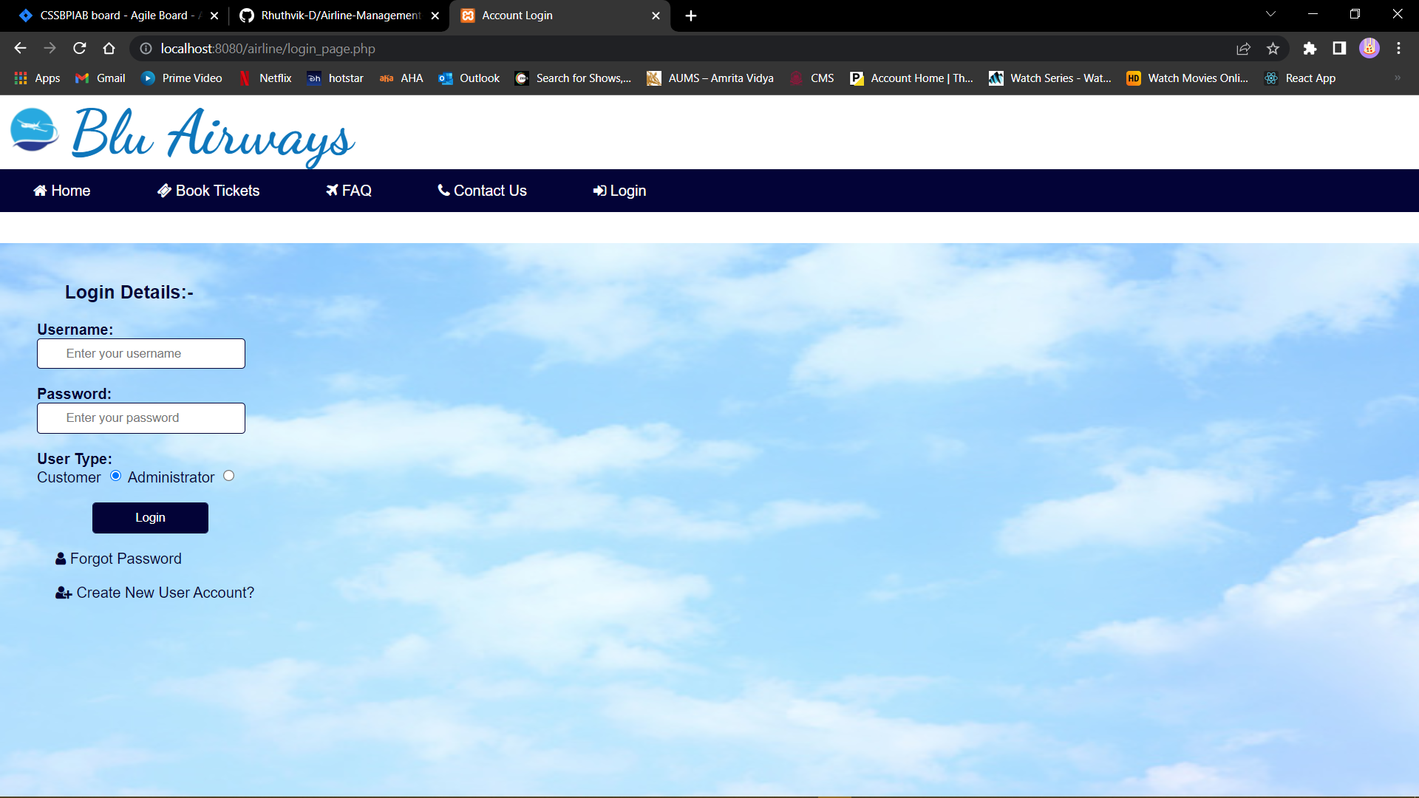

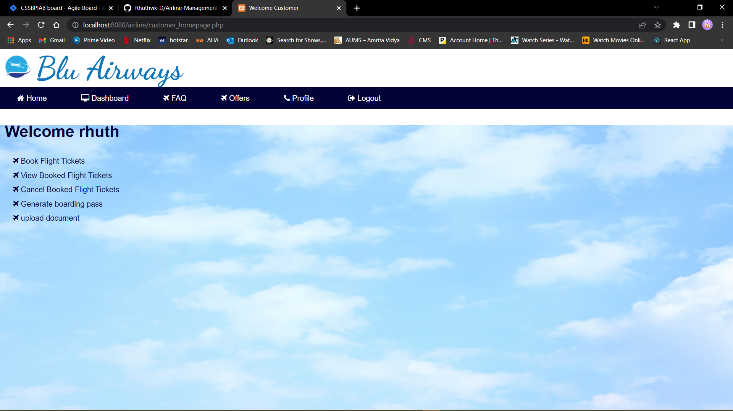

**Done in sprint2:**

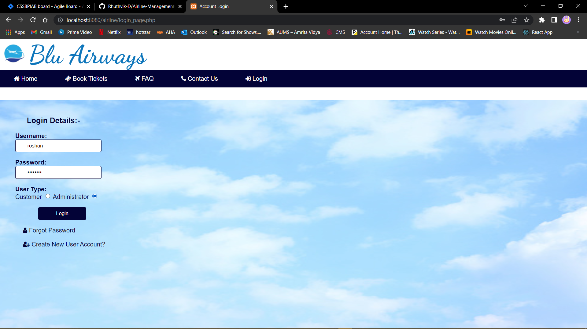

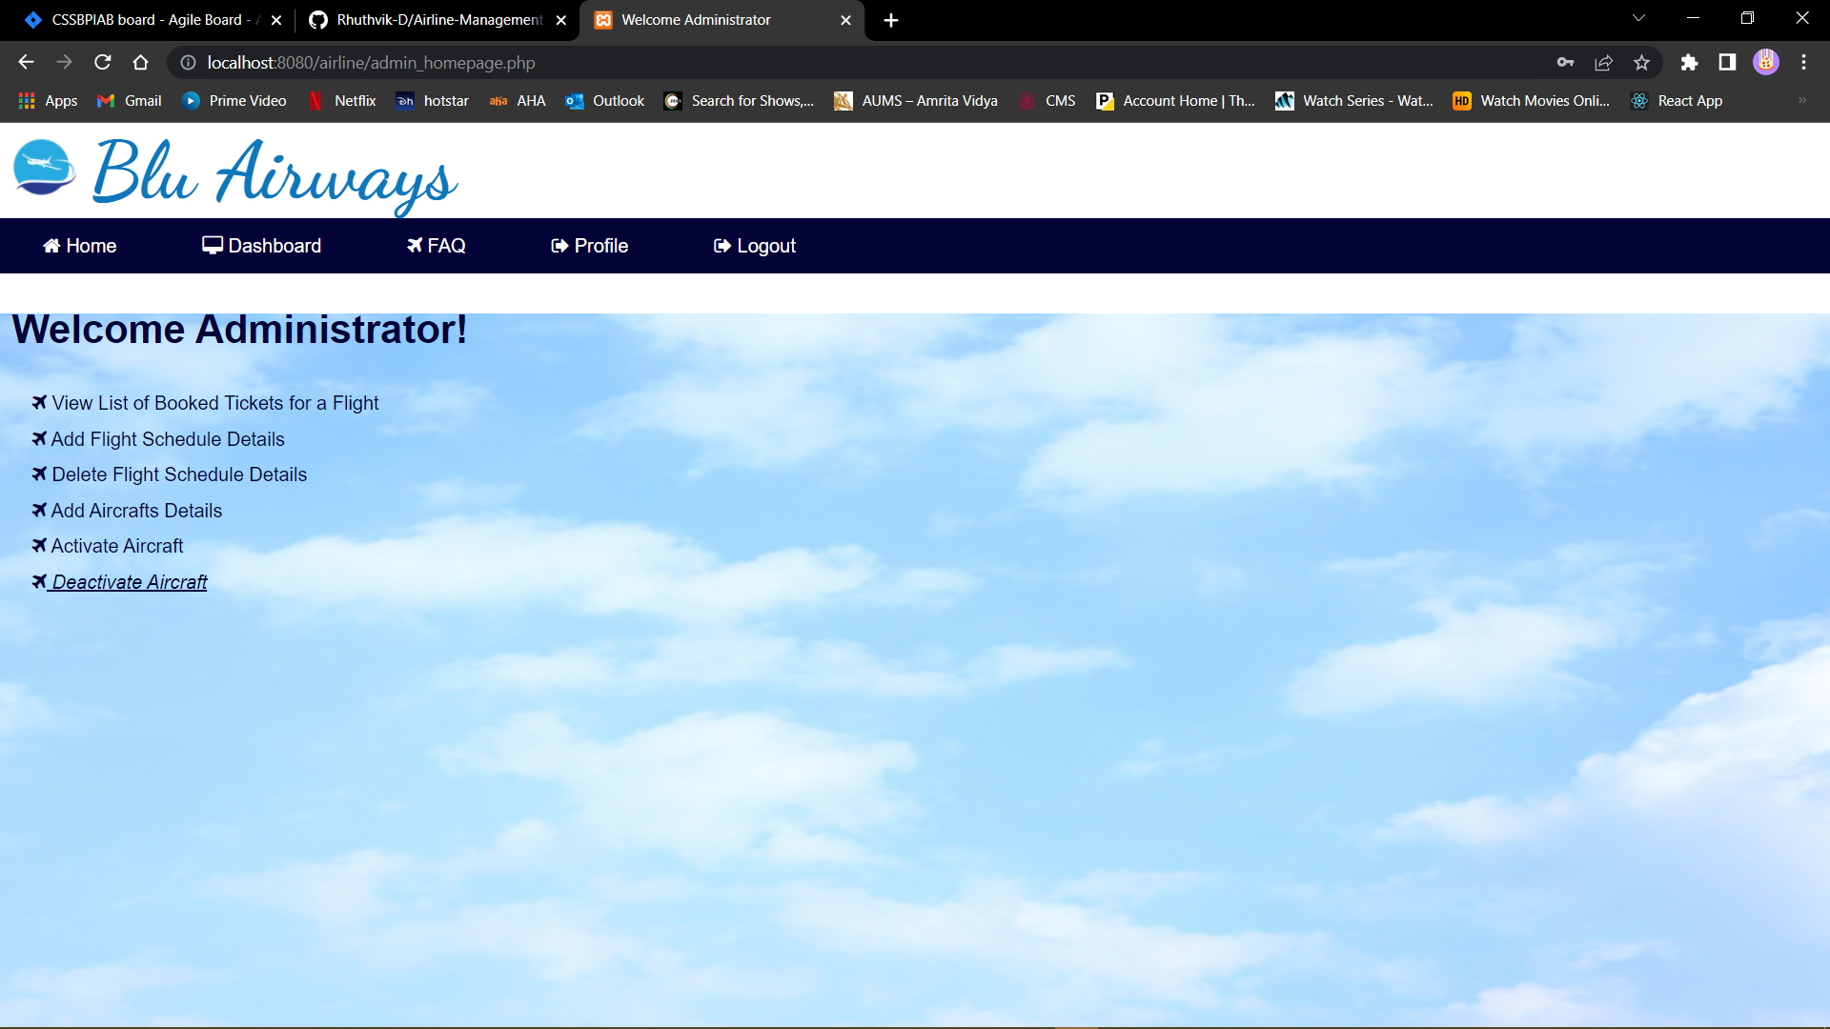

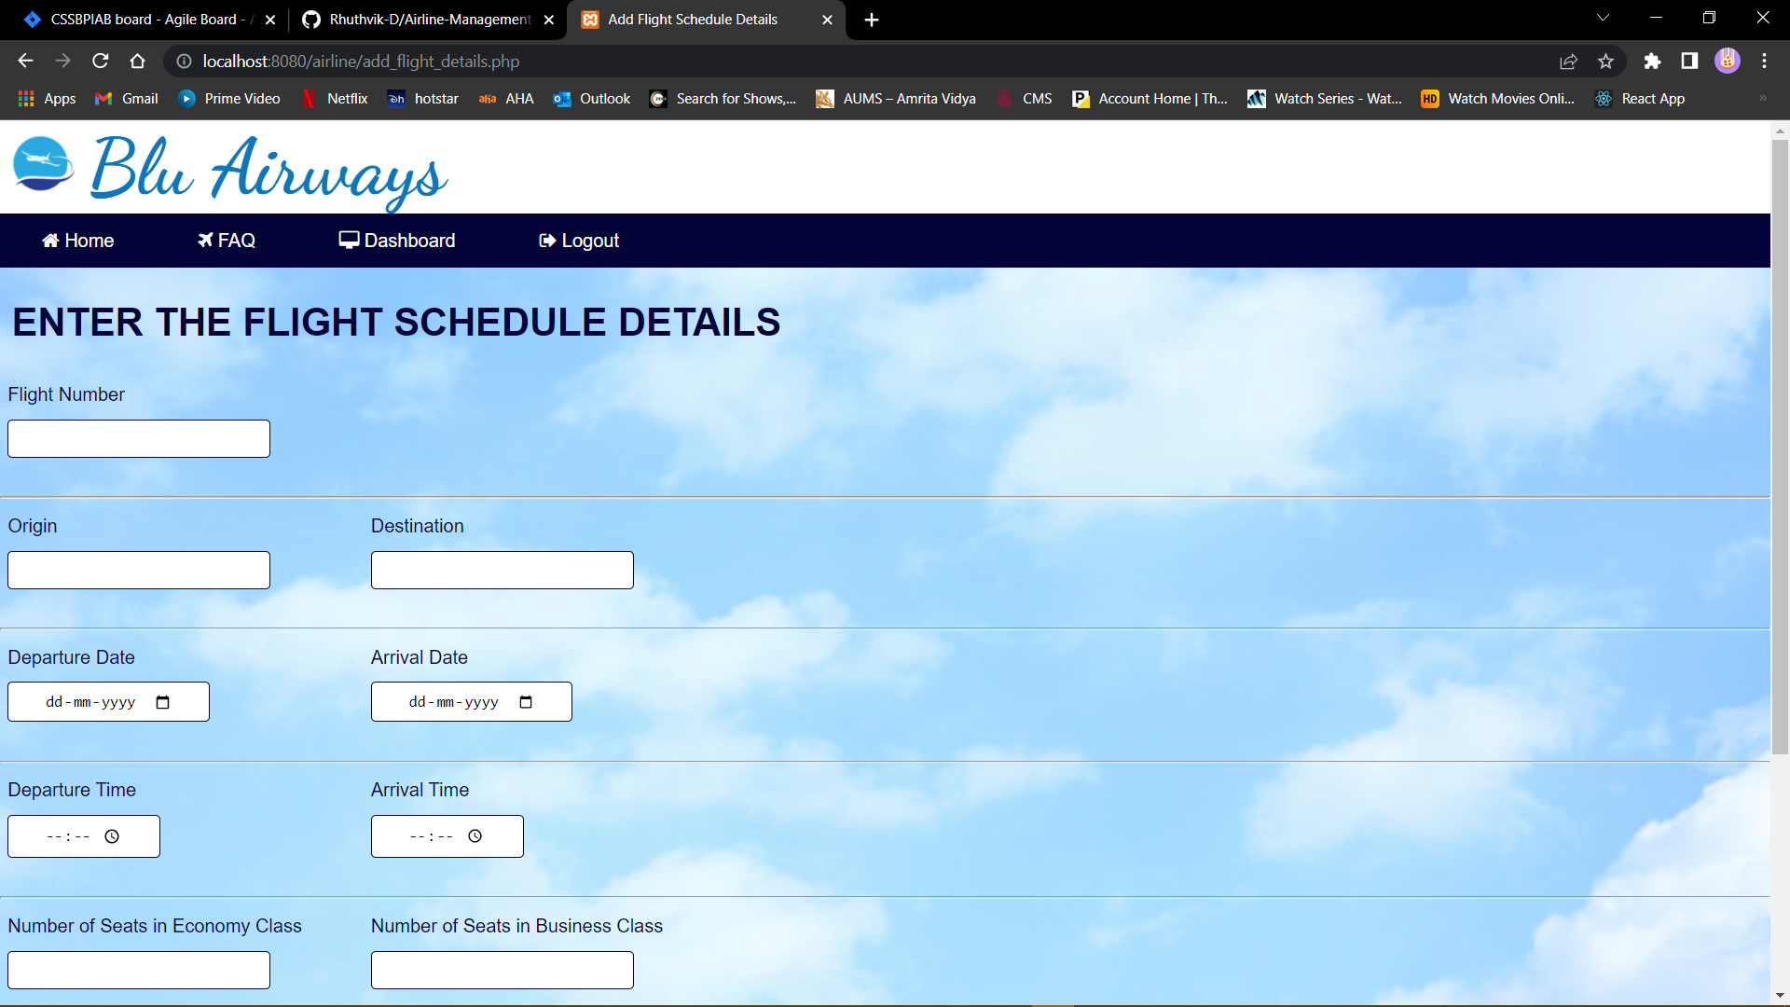

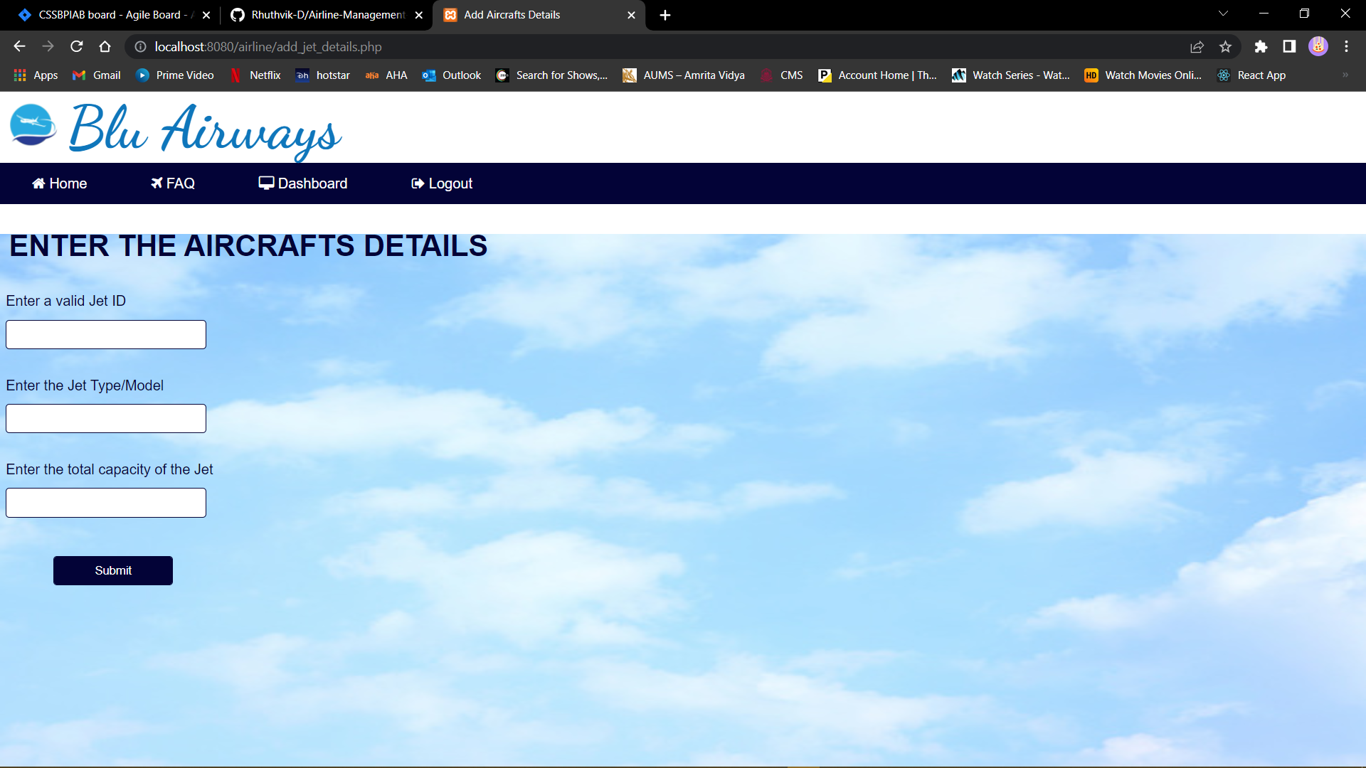

**10. Conclusion:**

The aim of this project was to develop a website that helps the admin to add, delete, and update data and user book the search flights, and book tickets. The system also allows the customer to cancel his/her reservation if any problem occurs. Also enables cart service which can be used for further bookings. Thus, the primary purpose of this software is achieved.